**A report on the concept of Bioinformatics & interpretation of the data provided**

**Table of Contents**

1. Introduction 3

2. Discussion and analysis 3

2.1 Introduction to Genomics and Bioinformatics 3

2.2 Genomics Analysis 4

2.3 Data Analysis in Biology 9

2.4 Transcriptomics analysis 11

2.5 Microbiome analysis 15

2.6 Multi- Omics Integration 18

3. Conclusion 21

Reference 22

# 1. Introduction

Bioinformatics is primarily a multidisciplinary field that incorporates computer science, mathematics, statistics, molecular biology, and genetics. Large-scale biological problems that require a lot of data are solved computationally (Davis et al., 2019). Modeling biological processes at the molecular level and making inferences from data are the most typical problems. A bioinformatics solution typically includes the following steps: Statisticians make use of data from biological systems. Make a computer simulation. solve an issue with computational modeling. Evaluate and test a computer algorithm. This chapter provides a succinct introduction to bioinformatics by first introducing biological terminology and then discussing some classic bioinformatics issues categorized by data source (Davis et al., 2019). Identifying homologs, aligning multiple sequences, looking for sequence patterns, and evolutionary analyses are all subproblems of sequence analysis. The study of DNA and protein sequences for indications of function is known as sequence analysis. Protein structures are three-layered information and the related issues are structure expectation (optional and tertiary), investigation of protein structures for signs with respect to work, and primary arrangement. Most of strategies for examining microarray information incorporate factual investigation, grouping, and bunching, while quality articulation information are normally addressed as lattices. Commonly, natural organizations like metabolic pathways, quality administrative organizations, and protein cooperation networks are displayed as diagrams. Building and analyzing large-scale networks are examples of related problems that can be solved using graph theoretic methods (Davis et al., 2019).

# 2. Discussion and analysis

## 2.1 Introduction of Genomics and Bioinformatics

## Genomics is the part of science that concentrates on the design, capability, advancement, and planning of genomes, which are the finished arrangement of DNA groupings that make up an organic entity (Steel, 2021). DNA sequencing technology has made it possible for researchers to sequence a large amount of genomic data quickly and affordably, which has revolutionized the field of genomics. The study of bioinformatics is a combination of computer science, biology, and statistics to analyze and interpret large biological datasets like genomic data. By providing tools and methods for managing, analyzing, and displaying genomic data, bioinformatics plays a crucial role in genomics research. Utilizing specialized search tools, genomic information can typically be accessed from a database by searching for particular genes or genomic regions of interest. The National Center for Biotechnology Information (NCBI) GenBank, the Ensembl database, and the UCSC Genome Browser are a few well-known sources of genomic data (Xia et al., 2019). The analysis of the DNA sequence is the next step after obtaining genomic data. Predicting the function of proteins encoded by the genome, identifying genes, and identifying genetic variations or mutations are all examples of this. Bioinformatics devices for genomic investigation incorporate arrangement programming for contrasting DNA successions, quality expectation programming, and instruments for practical explanation of qualities and proteins. One of the most important uses of bioinformatics and genomics is in personalized medicine, where genomic data are used to develop individualized treatments based on a person's genetic makeup. Genomic data, for instance, can be used to find genetic mutations that make people more likely to get certain diseases, like cancer, and to develop targeted treatments that are based on the patient's specific genetic profile.

Approaches or software gears for empathetic biological data are developed in the interdisciplinary field of bioinformatics. Bioinformatics is an interdisciplinary arena of knowledge that analyzes and understands biological information by combination computer science, figures, arithmetic, or engineering (Xia et al., 2019). In silico mathematical and statistical analyses of biological queries have utilized bioinformatics. Knowledge is gained through bioinformatics is the study of biological data using computers. These may include information from various experiments, patient statistics, scientific literature, and the genetic code. Bioinformatics research includes the development of data storage, retrieval, and analysis method development. A rapidly developing subfield of biology, bioinformatics incorporates concepts and approaches from informatics, statistics, mathematics, chemistry, biochemistry, physics, and linguistics (Xia et al., 2019).

It is extremely multidisciplinary. It can be utilized in numerous biological and medical contexts. The application of mathematical and informational methods, such as statistics, to the resolution of biological issues is known as computational biology, and it is also referred to as bioinformatics. Typically, this is done through the creation of computer programs, mathematical models, or a combination of the two. One of the main areas of bioinformatics is data mining and analysis of the data gathered by various genome projects (Liu et al., 2021). Additional fields include virtual evolution, systems biology, protein-protein interactions, sequence alignment, protein structure prediction, and systems biology. Bioinformatics is the science of building computer databases and algorithms to speed up and improve biological research. utilizing computer technology to manage biological data. Specifically, it is the art and science of creating computer databases and algorithms that speed up and simplify biological research. Data acquisition, storage, organization, archive, analysis, and visualization computational methods and tools for expanding the use of biological, medical, behavioral, or health data, are being developed, applied, or researched (Liu et al., 2021).

## 2.2 Genomics Analysis

DNA sequence, structural variation, gene expression, or regulatory and functional element annotation are examples of genomic features that can be measured, identified, or compared at the genome scale, is known as genomic analysis (Lappalainen et al., 2019). Bioinformatics and high-throughput sequencing or microarray hybridization are typically required for genomic analysis methods. An entire organism’s or cell type’s genetic makeup can be determined using a laboratory method. Changes in particular regions of the genome can be found using this approach. Scientists may be able to improvement a healthier sympathetic of the development of particular diseases, like cancer, thanks to these modifications. Clinicians and researchers can learn about differences and changes in a person’s genetic makeup through genome analyses, which helps them understand how genetics affects disease and treatment (Lappalainen et al., 2019).

**Technology for genome analysis**

The technology that are used in genome analysis are Next-Generation Sequencing (Giani et al., 2020). The massively parallel sequencing technology known as next-generation sequencing (NGS) provides extremely high throughput, scalability, and speed. The technology is utilized to ascertain the sequence of nucleotides in targeted DNA or RNA regions or entire genomes. The field of biology has been transformed by NGS, which has made it possible for labs to investigate biological systems on a scale never before seen. The complex genomics questions of today necessitate a depth of information that traditional DNA sequencing technologies cannot provide. This void has been filled by NGS, which is now a common tool for answering these questions (Giani et al., 2020).

1. Think about variation calls between genomes.

2. Export data into formats that are easy to use for analysis.

3. Annotate and filter the results to make them easier to analyze.

4. Establish a reference genome for future analyses.

Based on the activities involved in each branch, genomics can be broadly divided into three branches (Giani et al., 2020). Comparative genomics, functional genomics, and structural genomics are examples of these subfields. The following provides information about each branch. The study of the structure and sequence of DNA throughout a genome is known as structural genomics. The creation of chromosome maps, the production of expressed sequence tags from cDNA libraries, the sequencing and resequencing of entire genomes, and other methods can all be used to investigate structural genomics (Giani et al., 2020).

**Application of Next-Generation Technology**

The types of questions that scientists can ask and answer have been fundamentally altered by next-generation sequencing technology. A wide range of applications are made possible by innovative sample preparation and data analysis options (Giani et al., 2020). There are some application for Next-Generation Technology are:

1. Sequence entire genomes quickly.

2. Sequence the target areas in depth.

3. Quantify mRNAs for gene expression analysis or discover novel RNA variants and splice sites with RNA sequencing (RNA-Seq) (Giani et al., 2020).

4. Examine epigenetic factors like DNA methylation throughout the genome and interactions between DNA and proteins.

5. Study rare somatic variants, tumor subclones, and more by sequencing cancer samples.

6. Investigate the human gut flora (Giani et al., 2020).

**Functional Genomics**

The acquisition of genome and EST sequences was the primary focus of the first phase of genomics. The focus shifted to comprehending the function of the genes encoded in the genome as these sequences were accumulated in the database for various organisms (Kono and Arakawa, 2019). The dynamic aspects of transcription, translation, and protein-protein interaction are the primary focus of functional genomics. As a result, it can be described as an effort to comprehend the vast scope of genome function at various developmental stages and in various environmental conditions. Understanding the association between an creature’s phenotype or its genome is the focus of functional genomics (Kono and Arakawa, 2019). It tries to answer questions about how genes, RNA transcripts, and protein products use DNA. The genome of any organism is the same in every cell, with the exception of random mutations. However, only a portion of the genome’s information is utilized by each cell to express a particular set of genes. Thus, functional genomics describes the characterization of genome-wide genes at the transcriptome and proteome levels, respectively.

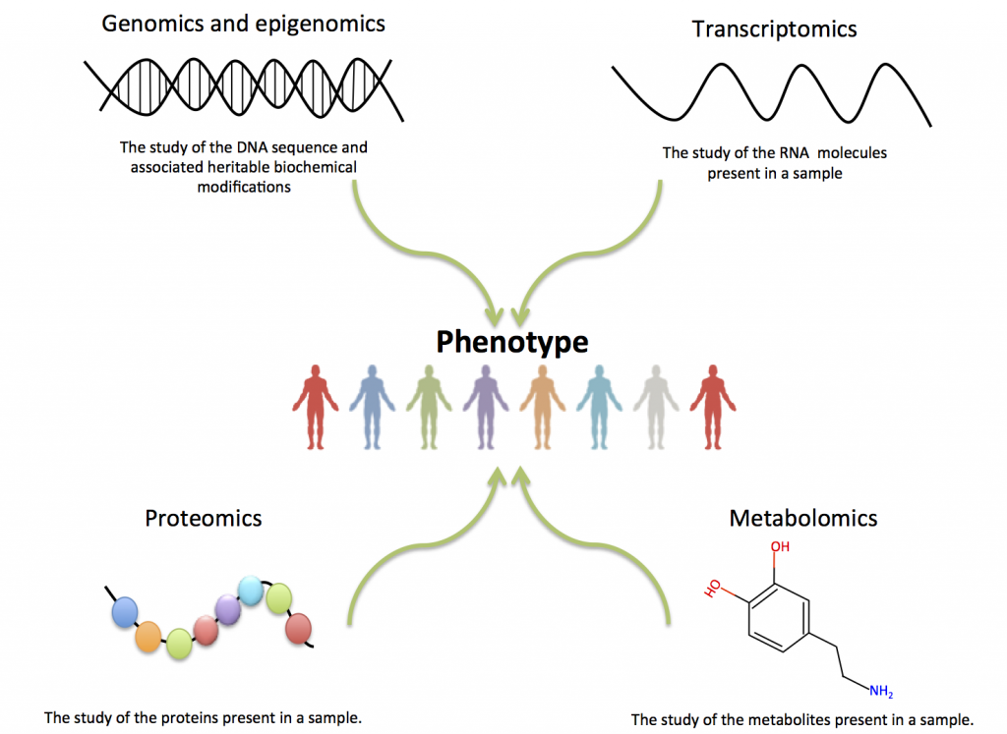

Figure 1: Functional Genomics

Source: (Kono and Arakawa, 2019)

**(i) Transcriptomics**

Nearly every cell in a multicellular organism has the same genome and, as a result, the same genes. However, not all genes are transcriptionally active in every cell; in other words, different patterns of gene expression are seen in different cells (Li and Fu, 2019. The wide range of physical, biochemical, and developmental differences that exist between various cells and tissues are based on these variations, which may also contribute to the distinction between health and disease. Thus, researchers can gain a deeper comprehension of what makes up a particular cell type and how changes in transcriptional activity may reflect or contribute to disease by collecting and comparing transcriptomes of various cell or tissue types. In organisms that are more complex, it appears that the proportion of transcribed sequences that do not code for proteins is higher (Li and Fu, 2019. Because of alternative splicing, RNA editing, or alternative transcription initiation and termination sites, each gene may also produce multiple mRNA variants. Transcript information, for instance, may assist in determining which genes are responsible for the distinctive properties of developmental plasticity and continuous cultured growth that stem cells possess, as well as which specific gene expression changes are linked to cancer. Additionally, by looking at the transcriptome, one can get a complete picture of which genes are active at various developmental stages (Li and Fu, 2019.

**(ii) Proteomics**

Another stage of functional genomics is proteomics, in which the genome can be characterized at the protein level. Proteins are the genome’s highest-level operating molecules, causing actual physiological effects (Zhao et al., 2021). Thus, the goal of proteomics is to better comprehend biological processes by attempting under various conditions, to describe the biological state and qualitative and quantitative changes in the protein content of cells and extracellular biological materials using a microscope. It involves characterizing and analyzing the functions of the genome-expressed proteins on a large scale. The most dynamic part of the genome is the proteome. Identification of the proteome, its quantification or differential analysis, protein-protein interactions, the investigation of post-translational modifications, and structural proteomics are some of the various methods used to study proteomics. In the tools for genomics section, various functional genomics at the proteomics level methods are listed (Zhao et al., 2021).

**(iii) Comparative genomics**

Numerous useful and model organisms now have a large number of genomes and EST sequences available. In this subfield of genomics, important trait-related genes are first characterized in model or related organisms whose genomes have already been sequenced (Zhao et al., 2021). Bioinformatics tools from the organism of interest are also used to identify genes that are similar. The study of the correlation between genome structure and function across various biological species or strains is a novel area of biological research. Using structural and functional genome comparisons, these similarities between organisms can be identified. As a result, comparative genomics is based on the idea that two organisms share characteristics that are frequently encoded in the DNA that is conserved between species. This means that the DNA sequence that encodes RNAs and proteins is conserved among the ancestor (Zhao et al., 2021). By examining individuals from the species who are genetically distinct in a variety of ways, differences that occur within a given species can be used to investigate this. Comparative genomics is essential for examining the evolutionary history of organisms by comparing species or strains that are related. It is possible to comprehend the significant differences and similarities between species as well as the minute differences between individuals within a species that can result in disease susceptibility in one species and resistance in another due to the shared evolutionary basis of all living organisms. By identifying functions for all metabolic genes, comparative genomics plays a crucial role in modeling and engineering and continues to increase in power and decrease in cost, complementing genetic and biochemical approaches to metabolism analysis (Zhao et al., 2021).

## 2.3 Data Analysis in Biology

In both academic and industrial research, data analysis is a crucial part of biology. The field of biological data analysis has moved beyond the realm of traditional statistical methods with the development of high-throughput methods and now encompasses the data analytic and machine learning communities as a whole (Mahmud et al., 2021). The biological analysis is a method of science that brings together biological content and analytical tools in one place. This allows researchers to gain a fundamentally deeper and broader comprehension of the biological relationships and processes that are known to be connected to experimental observations and to translate that comprehension into concrete hypotheses and insights that can be implemented. Basic data analysis results can be turned into useful research outcomes by biological analysis, allowing researchers to use their findings to make educated decisions, develop well-formed, testable hypotheses, plan follow-up experiments, and provide convincing biological and mechanistic evidence (Mahmud et al., 2021).

In order to uncover new information from a variety of biological data sets, Profacgen now offers comprehensive data analysis services (Chen et al., 2020). To answer our clients’ specific technological or biological research questions, our team has developed effective data analysis pipelines that combine mathematics, statistics, and programming. Additionally, our team is proficient in cutting-edge data mining methods that have been developed to deal with difficult data analysis issues involving computation-intensive tasks as well as noisy and incomplete data. Our objective is to make it possible for researchers to draw meaningful conclusions from a wide range of biological, pharmaceutical, and clinical data (Chen et al., 2020).

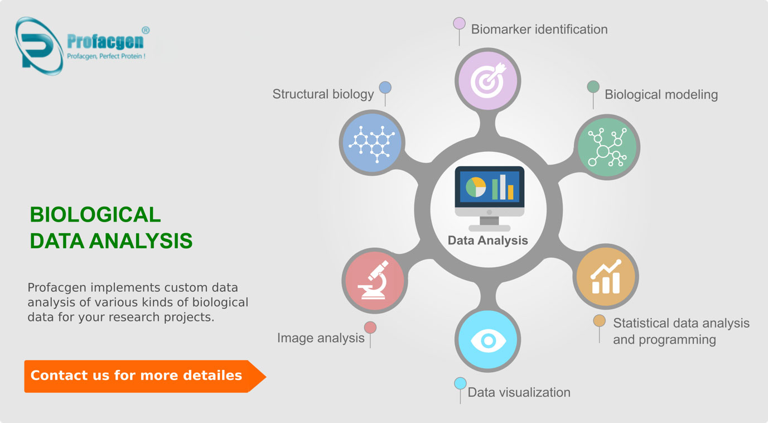

Figure 2: Data Analysis in Biology

Source: (Chen et al., 2020)

The following application areas are currently the focus of their data analysis:

**1. Biomarker identification**

A variety of data types from ChIP-Seq, RNA-Seq, miRNA sequencing, 4C-Seq, microarray, and mass spectrometry experiments are utilized for the rapid identification and validation of biomarkers (Li et al., 2022).

**2. Biological modeling**

Using techniques like graph-theoretic approaches, scientific evidence supports systematic reconstruction and analysis of biological pathways and networks from observed data (Li et al., 2022). Exploring the behavior of networks, integrating prior knowledge, and differential analysis within the context of global integrated experimental data are effective methods for analyzing complex systems that have a lot of potential for biomedical applications (Li et al., 2022).

**3. Image analysis**

Techniques for microscopy are essential for studying biological systems on a variety of scales, including the structure of biomolecules and the entire body of cells and organs. Through image-analysis solutions, Profacgen contributes to the understanding of biological systems with cutting-edge tools and techniques for interactive image segmentation and quantitative information extraction from optical and electron microscopy data (Schwacke et al., 2019).

**4. Statistical data analysis and programming**

Quality control, outlier detection, programming, regression, clustering, classification, error rates, resampling, and testing are all examples of statistical methods that are developed and utilized in biological research (Schwacke et al., 2019). Other examples include data management, extensive univariate and multivariate analyses, and big data analytics for healthcare, and so on.

**5. Data visualization**

Data visualization is an essential part of the biological sciences because it makes it possible to share knowledge and understand the data after it has been acquired (Schwacke et al., 2019). Profacgen employs cutting-edge software tools for the visualization of sequences, alignments, phylogenies, microarrays, macromolecular structures, networks, and a variety of other data types in order to meet the challenge posed by the rapid increase in data volume and complexity (Schwacke et al., 2019).

**6. Structural biology**

Projects in structural biology can produce a lot of data. Profacgen has a professional team of structural biologists who can help with the analysis and model reconstruction of high-resolution macromolecular structures based on X-ray crystallography, NMR, or EM data (Schwacke et al., 2019). Reliability is also evaluated and ensured through model quality assessment and refinement. The biological significance of structural aspects and their interpretation can also be discussed with a scientist.

## 2.4 Transcriptomics analysis

The term “transcriptome,” initially used to refer to a whole series of transcripts, has now been given to Charles Auffray. Transcriptomics is the investigation of the "transcriptome." Today, it is generally accepted that the term "transcriptome" refers to the entire collection of each of the ribonucleic acid (RNA) molecules expressed inside a particular entity, like a tissue, cells, or organism. The field of transcriptomics covers all RNA-related research (Rao et al., 2021). This covers things like their levels of transcription and expression, roles, habitats, movement, and decomposition. The architecture of transcripts or its parent genes in terms of start locations, 5′ and 3′ end sequences, posttranscriptional alterations, or merging patterns are also included. Containing messenger RNAs (mRNAs) and microRNAs (miRNAs), or numerous long non-coding RNAs, transcriptomics encompasses all transcript types (lncRNAs) (Rao et al., 2021).

**High-Throughput Transcriptomic Technologies Evolution**

Up until recently, the complete analysis of the transcriptome was not feasible because it is challenging and technologically complex to capture whole catalogs of transcripts or their variants. A variety of advanced technologies have been created over time to characterize and measure transcript expression (Rao et al., 2021). The phrase "RNA sequencing", which refers to a number of sequencings of next-generation methods for identifying the sequence and possibly also the amounts of RNA transcripts, has become more popular in recent years (Zhao et al., 2021).

At current, still sequencing technology includes several problems for users, containing cost, complexity, or availability as well as mistake vulnerability of the sequence assembly. Here, for these types of reasons, the technology of array-based is broadly utilized into transcriptome profiling (Zhao et al., 2021). Though, compared to approaches of new sequencing, which are capable to distribute readings on particular transcription limitations as well as unmapped transcripts without any needing transcript probes or predefined genes, the technology of array is partial via probe-based microarrays nature. Through the beginning of RNA-seq, here the sequencing opportunity of the whole transcriptome has to convert a truth (Zhao et al., 2021).

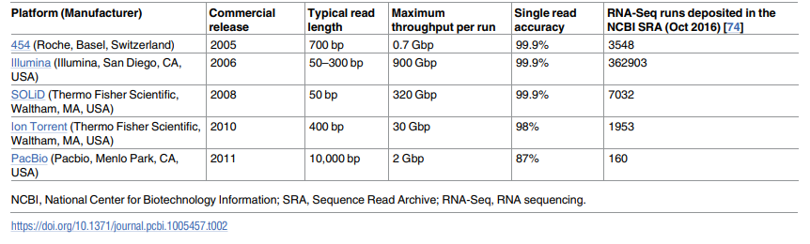

Figure 3, Sequencing technology platforms commonly used for RNA-Seq

Source: (Zhao et al., 2021)

Traditional techniques, such as EST sequencing, typically only detect the more numerous transcripts, while RNA-seq, at that time used with sufficient sequencing depth ( near 100 to 1000 reads/base pair of the transcript), can offer an almost comprehensive capture of a transcriptome. Additionally, by a broad dynamic variety of expression stages, RNA-seq enables a complete genome-wide assessment of transcripts (Aldridge and Teichmann, 2020).

As briefed in the below-mentioned Figure 2, most approaches of RNA-seq to date have utilized indirect methodologies inside which the removed mRNAs & entire RNAs is initially changed in a cDNAs library comprising sequencing adapters (Aldridge and Teichmann, 2020). A technology of DNA sequencing (high-throughput ) is then utilized to arrange fragments of cDNA from 1 end and together ends, rendering an outcome that is included of rapid sequences. Short reads that are produced are preprocessed to reduce errors of sequencing before being assembled in lengthier sequences that are thought to correspond to RNAs inside the unique sample (Aldridge and Teichmann, 2020).

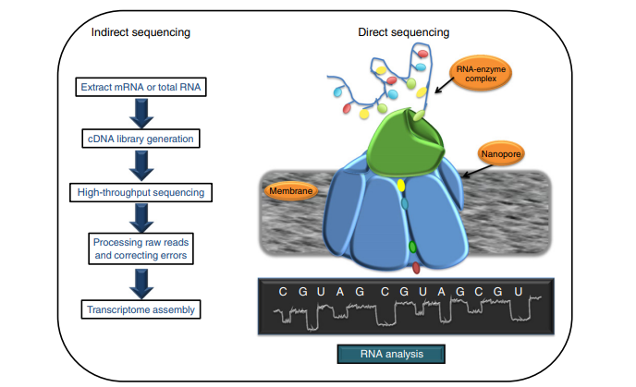

Figure 4, Indirect and direct approaches to RNA-seq

Source: (Aldridge and Teichmann, 2020)

**Uses of transcriptome analysis**

Usually, the transcriptome Analysis is greatest normally used to comparation exact pairs of examples. The variances may be because of diverse external environmental situations, e.g., hormonal impacts as well as toxins. More usually, states of health or disease are equated. For instance, in cancer, typically transcriptomics analyses discover classification, pathogenesis mechanisms, as well as result prediction (Karlsson et al., 2021). The studies of transcriptome can categorize cancer outside histopathology or anatomical location. Result predictions can implement benchmarks which is gene-based to forecast tumor prognosis as well as the therapy response. Thus, these approaches are previously in utilized for modified medicine, individualized patient therapies (cancer). Tissues or organisms at numerous phases of development may be molecularly considered. The mechanisms of cellular differentiation and embryonic development can be better understood by studying the transcriptomes of stem cells. As for its wide-ranging approach, transcriptome analysis is usually a great source in order to recognize aims for treatment (Karlsson et al., 2021).

**Transcriptome Sequencing**

The overview of huge-throughput NGS called (next-generation sequencing) technologies transformed transcriptomics. This technological development removed numerous challenges posed via hybridization-depend microarrays or Sanger sequencing-based methods that were earlier used for monitoring gene expression (Karlsson et al., 2021). Basically, a typical experiment of RNA-Seq contains of isolating RNA, changing it to the cDNA called (complementary DNA), formulating the library of sequencing, as well as sequencing it on the next-generation sequencing platform. Though, numerous experimental details, reliant on an expert’s objectives, must be measured before executing the RNA-Seq. These contain the use of technical or biological replicates, sequencing depth, and wanted coverage beyond the transcriptome. Here, in a few cases, these options of experiments will have a slight effect on the data quality (Yu et al., 2019). Nevertheless, in numerous cases the experts and researcher must wisely plan the experiment, putting importance on the balance among high-quality outcomes as well as time or monetary investment.

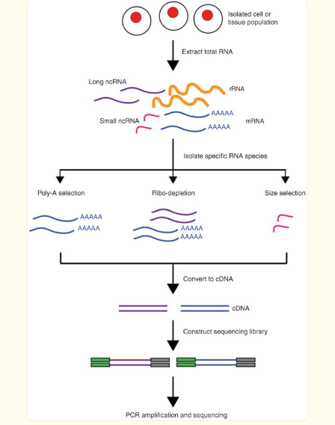

Figure 5, Overview of RNA-Seq

Source: (Yu et al., 2019)

First, RNA is removed from the selected biological material (e.g., cells, tissues). Another, in order to isolate subsets of RNA molecules, a particular methodology is used, like the poly-A selection process to enrich polyadenylated transcripts and the protocol of ribo-depletion to eliminate ribosomal RNAs. Furthermore, the RNA is changed to complementary DNA through sequencing adaptors and reverse transcription is ligated to end of the fragments of cDNA (Yu et al., 2019). Ensuing amplification via PCR, the library of RNA-Seq is complete for sequencing.

## 2.5 Microbiome analysis

Analyzing the microbial populations on and in the human body is known as "human microbiome analysis." Understanding the function of microorganisms in health and disease is the aim to human microbiome profiling investigations. Using the next-generation sequencing, investigations have been completed possible that can now examine the genomes of all types of microbial communities, even those of unculturable organisms (Bharti and Grimm, 2019). Prior to this, the analysis of human microbiome samples depended on labor- and time-intensive microbiological procedures that involved growing or isolating individual organisms before phenotypic and genotypic evaluation. These previous methods did not allow for the profiling of microbial communities inside a single sample. The released RNAs encoded by a collection of species in a complex sample can be better understood through microbial transcriptomics, also known as meta-transcriptomics. Researchers can measure changes in gene expression, foretell therapy resistance or susceptibility, comprehend host-pathogen immunological interactions, and monitor disease progression using high-quality metatranscriptomics data (Bharti and Grimm, 2019).

Metagenomics, to put it simply, is the research of genetic material extracted straight from environmental examples, like those found on human bodies. The first genetic analyses of the microbiome entailed cultivating the microbiota using conventional microbiology methods, followed by molecular cloning & gene sequencing to create a metagenomic description of a microbiome sample (Bharti and Grimm, 2019). However, because several microorganisms are still not culturable, a full genome profile of a microbiome cannot be obtained for research using conventional microbiology methods.

Due to its high throughput and simultaneous developments in bioinformatics for data interpretation, sequencing of next-generation had made it likely to analyze the microbiome without the need for culture. Due to NGS, there are currently a large number of studies linking the microbiome to various diseases, including obesity, autism, and cancer, as well as its impact on cancer treatment (Bharti and Grimm, 2019). [Microbiome study and its health](https://www.thermofisher.com/in/en/home/life-science/sequencing/sequencing-education/microbiome-research-next-generation-sequencing/microbiome-influence-human-health.html) impact continues to raise quickly as the genomic microbial databases raise and additional insights are collected from basic study or clinical surveys. Learn about a few of the basic NGS concerns in this article, as well as the several NGS techniques that can help your microbiome study.

**Considerations for microbiome research using NGS**

NGS-based metagenomic sequencing is an effective method for quantitatively characterising microbiomes. It gives insight in to the microbial populations and aids in the discovery of microbes that aren't culturable as well as may be in fairly low abundance and are therefore difficult to find using conventional techniques (Blaser et al., 2021). A good microbiome study must take into account a variety of elements. Sequencing coverage or throughput are crucial ideas to make sure the right data is gathered to answer your scientific concerns and goals, especially for NGS investigations. You can be sure you have just enough information to genetically characterize the microbiome if your coverage and throughput are adequate. This contains counting the OTUs called operational taxonomic units in the samples (Blaser et al., 2021).

Using specific taxonomic markers, OTUs are groups of species that are grouped together in the context of NGS based on DNA sequence similarity. By apply for this post to sequence challenging areas of the genome, long NGS processing reads can assist address coverage problems (Blaser et al., 2021). In addition to being more distinctive, longer sequencing reads can be more precisely categorised for an unidentified species that is not listed in the genomic database or allocated to a relevant reference genome. Thus, an extra correct microbe’s classification in the microbiome might be attained. The correctness of sequencing is a significant consideration in order to confirm the right sequencing alternatives are being named. Here, the weak accuracy may lead to an increase in distinct OTUs and therefore an miscalculate in microbiome variety (Blaser et al., 2021).

**Shotgun metagenomic sequencing**

Shotgun sequencing is usually a technique for randomly arranging the DNA strands in a sample. The sample's DNA is cut into more manageable pieces before being sequenced using NGS. Shotgun metagenomic sequencing's untargeted nature enables researchers to investigate every microbial genome without having any prior information about the community (Schlaberg, 2019). It offers a method for finding microorganisms that are inculpable.

Rare and low abundance microbial species can also be found in the microbiome when sequencing is done with a high enough throughput.

**Targeted metagenomic sequencing**

[The approaches](https://www.thermofisher.com/in/en/home/life-science/sequencing/sequencing-education/next-generation-sequencing-basics/targeted-sequencing-approaches.html) of targeted sequencing permit researchers to concentration their study on specific genes and genomic regions. Targeted NGS can be utilized to enhance coverage, make analysis and interpretation simpler, and reduce overall sequencing workflow costs by making use of current genomic knowledge (Schlaberg, 2019). For characterising bacterial populations, doing taxonomical research, and identifying species, 16S ribosomal RNA (rRNA) decoding is the most popular technique. Since it is conserved among many bacterial species and archaea, a 16S rRNA gene are utilised in phylogenetic investigations (Schlaberg, 2019).

9 hypervariable regions (V1-V9) found in the bacterial 16S gene are involved in the small ribosomal unit's secondary structure (Fig 1).

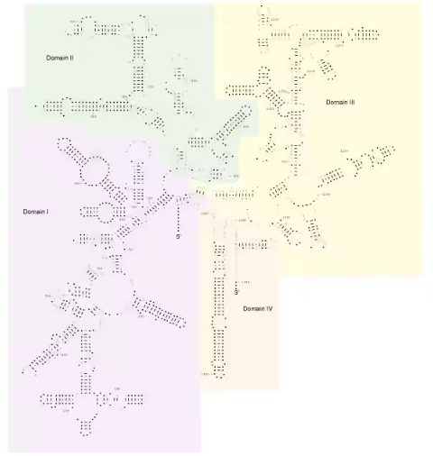

Figure 6;16S rRNA secondary structure

Source: (Schlaberg, 2019)

## 2.6 Multi- Omics Integration

The term "multi-Omic integration" can be used to refer to both the vertical integration of different 'omes produced in the same sample group as well as the examination of a specific 'ome across various studies (for example, a meta-analysis). Upcoming DNA sequencing, RNA-seq transcriptome measurements, the SNP-chip profiling, SWATH-based proteomics, as well as UPLC-MS or GC-MS metabolomics methods have all made it much simpler and less expensive to gather comprehensive, multi-omics data over the past ten years (Subramanian et al., 2020).

Even while it's getting easier to acquire large-scale omics data and multi-omics research are popping up all the time, true multi-omics integration is still quite difficult to do (Subramanian et al., 2020). This is due to the fact that several of the specialized analytical tools & experimental setups that are typically utilized for specific omics disciplines (such as genomics, transcriptomics, or proteomics) aren’t suitable enough to allow for accurate comparisons as well as intelligent integration across various omics disciplines. In addition, for illustration, the recommended collecting strategies, storage methods, necessary volume, or preferred biological sample selection employed for genomics investigations are frequently inappropriate for metabolomics, proteomics, or transcriptomics (Subramanian et al., 2020).

**Multi-omics Data Integration**

The main obstacle to all multi-omics investigations has been identified as data integration. This is so because, as was already mentioned, data integration calls for input or interpretation from a broad series of scientists and specialists (Argelaguet et al., 2018). A few of these experts are required to assess the calibre or reliability of the research's (experimental) design and the calibre of the information gathered from the instrument. There are several methods that can be used to analyse and interpret multi-omics data, presuming that the data are good quality and have been appropriately validated (Argelaguet et al., 2018).

**Post-Analysis Data Integration Approaches**

In such post-analysis information addition strategy, several omics data sets is initially evaluated independently, or then essential functions are "networked" and stitched together by the synthesis of important properties at shared nodes into a broad model pathway. Usually, this method has been applied into a wide variety of investigations, such as the evaluation on biological wastewater dealing plants and investigation of microbial resilience in marine sediments following the oil spill (Argelaguet et al., 2018).

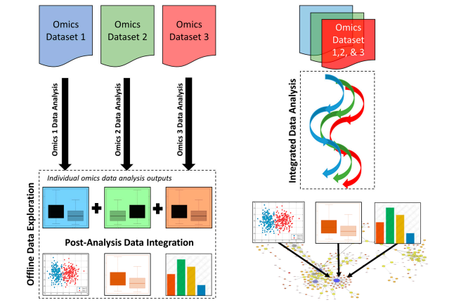

Figure 7, The main distinctions between integrated data analysis (right) and post-analysis statistics integration (left) for multi-omics sets of data

Source: (Argelaguet et al., 2018)

Integrated Data Analysis Approaches

The approach of integrated data analytic utilizes specialised technologies to combine several omics data sets before engaging in any additional data analysis and interpretation, in opposed to post-analysis data integration. This makes it possible to quantitatively derive the shared similarities across each omics technique and platform rather than depending on interpretation or prejudice on the part of humans (Bors, 2018).

**System modeling**

System modelling is a third method of data integration that is available in addition to integrated methodological approach and post-analysis data integration methods. Techniques like systems modelling or simulation are valuable for comprehending or even forecasting the particulars of intricate biological systems. Model-based integration techniques compare new experimental results to modelled expectations by using a clear grasp of the system under investigation (Bors, 2018).

**Challenges in Multi-Omics Integration**

**The Omics Data Sets nature**

Omics information are by nature quite erratic and noisy. In addition, the majority of omics data is solely qualitative in the nature, made it exceedingly challenging to replicate and much more challenging to compare. Integration of numerous omics, especially from various sources, becomes challenging, if not almost impossible, only when qualitative data are provided (Pinu et al., 2019).

**Dispersed Data Sets or Non-Interoperable Tools**

Software and data tools for integrating multiple omics are widely available. Several of the system are effective design or maintained, and the multi-omics databases that are readily available are frequently of extremely high quality or exceptionally well-curated (Pinu et al., 2019). But it's obvious that some researchers—like several of the writers—may not be aware of all of the resources or what they might have to offer. This issue might be brought on by the overwhelming number of tools available or the absence of a centralized database that lists, links, and evaluates or summaries various tools (Pinu et al., 2019).

# 3. Conclusion

This study states of the concept of bioinformatics and describes these various aspects. The overview of Genomics or Bioinformatics are investigated in this report and it’s importance are discussed in this report. The Genomics analysis are conducted in this report as well as in Biology, the data analysis concept is discussed in this report that provide a clear understanding to the reader. In addition, the Transcriptomics analysis are discussed in this report also the use of Transcriptomics analysis is discussed in this report. This report also describe the microbiome analysis and microbiome research using NGS are clearly discussed in this report.

Furthermore, this report also investigated the Multi-Omics Integration and the concept of Multi-omics Data Integration are discussed in this report. The approaches of Multi-omics Data Integration are discussed as well as the challenges are discussed in this study.

# Reference

Chen, C., Chen, H., Zhang, Y., Thomas, H.R., Frank, M.H., He, Y. and Xia, R. (2020). TBtools: An Integrative Toolkit Developed for Interactive Analyses of Big Biological Data. *Molecular Plant*, 13(8), pp.1194–1202. doi:10.1016/j.molp.2020.06.009.

Davis, J.J., Wattam, A.R., Aziz, R.K., Brettin, T., Butler, R., Butler, R.M., Chlenski, P., Conrad, N., Dickerman, A., Dietrich, E.M., Gabbard, J.L., Gerdes, S., Guard, A., Kenyon, R.W., Machi, D., Mao, C., Murphy-Olson, D., Nguyen, M., Nordberg, E.K. and Olsen, G.J. (2019). The PATRIC Bioinformatics Resource Center: expanding data and analysis capabilities. *Nucleic Acids Research*. doi:10.1093/nar/gkz943.

Giani, A.M., Gallo, G.R., Gianfranceschi, L. and Formenti, G. (2020). Long walk to genomics: History and current approaches to genome sequencing and assembly. *Computational and Structural Biotechnology Journal*, 18, pp.9–19. doi:10.1016/j.csbj.2019.11.002.

Kono, N. and Arakawa, K. (2019). Nanopore sequencing: Review of potential applications in functional genomics. *Development, Growth & Differentiation*, 61(5), pp.316–326. doi:10.1111/dgd.12608.

Lappalainen, T., Scott, A.J., Brandt, M. and Hall, I.M. (2019). Genomic Analysis in the Age of Human Genome Sequencing. *Cell*, [online] 177(1), pp.70–84. doi:10.1016/j.cell.2019.02.032.

Li, X. and Fu, X.-D. (2019). Chromatin-associated RNAs as facilitators of functional genomic interactions. *Nature Reviews Genetics*, [online] 20(9), pp.503–519. doi:10.1038/s41576-019-0135-1.

Li, X.-Y., Xiang, J., Wu, F.-X. and Li, M. (2022). NetAUC: A network-based multi-biomarker identification method by AUC optimization. *Methods*, [online] 198, pp.56–64. doi:10.1016/j.ymeth.2021.08.001.

Liu, H., Xin, B., Zheng, J., Zhong, H., Yu, Y., Peng, D. and Sun, M. (2021). Build a Bioinformatic Analysis Platform and Apply it to Routine Analysis of Microbial Genomics and Comparative Genomics. [online] doi:10.21203/rs.2.21224/v5.

Machine learning for integrating data in biology and medicine: Principles, practice, and opportunities. (2019). *Information Fusion*, [online] 50, pp.71–91. doi:10.1016/j.inffus.2018.09.012.

Mahmud, M., Kaiser, M.S., McGinnity, T.M. and Hussain, A. (2021). Deep Learning in Mining Biological Data. *Cognitive Computation*, 13(1), pp.1–33. doi:10.1007/s12559-020-09773-x.

Schwacke, R., Ponce-Soto, G.Y., Krause, K., Bolger, A.M., Arsova, B., Hallab, A., Gruden, K., Stitt, M., Bolger, M.E. and Usadel, B. (2019). MapMan4: A Refined Protein Classification and Annotation Framework Applicable to Multi-Omics Data Analysis. *Molecular Plant*, [online] 12(6), pp.879–892. doi:10.1016/j.molp.2019.01.003.

Steel, J.J. (2021). Genome Analysis of SARS-CoV-2 Case Study: An Undergraduate Online Learning Activity to Introduce Bioinformatics, BLAST, and the Power of Genome Databases †. *Journal of Microbiology & Biology Education*, 22(1). doi:10.1128/jmbe.v22i1.2245.

Xia, E., Li, F., Tong, W., Li, P., Wu, Q., Zhao, H., Ge, R., Li, R., Li, Y., Zhang, Z., Wei, C. and Wan, X. (2019). Tea Plant Information Archive: a comprehensive genomics and bioinformatics platform for tea plant. *Plant Biotechnology Journal*, 17(10), pp.1938–1953. doi:10.1111/pbi.13111.

Zhao, Z., Zhang, K.-N., Wang, Q., Li, G., Zeng, F., Zhang, Y., Wu, F., Chai, R., Wang, Z., Zhang, C., Zhang, W., Bao, Z. and Jiang, T. (2021). Chinese Glioma Genome Atlas (CGGA): A Comprehensive Resource with Functional Genomic Data from Chinese Glioma Patients. *Genomics, Proteomics & Bioinformatics*, 19(1), pp.1–12. doi:10.1016/j.gpb.2020.10.005.

Rao, A., Barkley, D., França, G.S. and Yanai, I. (2021). Exploring tissue architecture using spatial transcriptomics. *Nature*, [online] 596(7871), pp.211–220. doi:10.1038/s41586-021-03634-9.

Zhao, E., Stone, M.R., Ren, X., Guenthoer, J., Smythe, K.S., Pulliam, T., Williams, S.R., Uytingco, C.R., Taylor, S.E.B., Nghiem, P., Bielas, J.H. and Gottardo, R. (2021). Spatial transcriptomics at subspot resolution with BayesSpace. *Nature Biotechnology*, 39(11), pp.1375–1384. doi:10.1038/s41587-021-00935-2.

Aldridge, S. and Teichmann, S.A. (2020). Single cell transcriptomics comes of age. *Nature Communications*, [online] 11(1). doi:10.1038/s41467-020-18158-5.

Karlsson, M., Zhang, C., Méar, L., Zhong, W., Digre, A., Katona, B., Sjöstedt, E., Butler, L., Odeberg, J., Dusart, P., Edfors, F., Oksvold, P., von Feilitzen, K., Zwahlen, M., Arif, M., Altay, O., Li, X., Ozcan, M., Mardinoglu, A. and Fagerberg, L. (2021). A single–cell type transcriptomics map of human tissues. *Science Advances*, 7(31). doi:10.1126/sciadv.abh2169.

Yu, K., Chen, B., Aran, D., Charalel, J., Yau, C., Wolf, D.M., van ‘t Veer, L.J., Butte, A.J., Goldstein, T. and Sirota, M. (2019). Comprehensive transcriptomic analysis of cell lines as models of primary tumors across 22 tumor types. *Nature Communications*, [online] 10(1), p.3574. doi:10.1038/s41467-019-11415-2.

Bharti, R. and Grimm, D.G. (2019). Current challenges and best-practice protocols for microbiome analysis. *Briefings in Bioinformatics*, 22(1), pp.178–193. doi:10.1093/bib/bbz155.

Blaser, M.J., Devkota, S., McCoy, K.D., Relman, D.A., Yassour, M. and Young, V.B. (2021). Lessons learned from the prenatal microbiome controversy. *Microbiome*, 9(1). doi:10.1186/s40168-020-00946-2.

Schlaberg, R. (2019). Microbiome Diagnostics. *Clinical Chemistry*, [online] 66(1), pp.68–76. doi:10.1373/clinchem.2019.303248.

Argelaguet, R., Velten, B., Arnol, D., Dietrich, S., Zenz, T., Marioni, J.C., Buettner, F., Huber, W. and Stegle, O. (2018). Multi‐Omics Factor Analysis—a framework for unsupervised integration of multi‐omics data sets. *Molecular Systems Biology*, [online] 14(6). doi:10.15252/msb.20178124.

Bors, D. (2018). Data Analysis for the Social Sciences : Integrating Theory and Practice. *Data Analysis for the Social Sciences*, [online] pp.1–664. Available at: https://www.torrossa.com/gs/resourceProxy?an=5017914&publisher=FZ7200 [Accessed 4 Jan. 2023].

Pinu, F.R., Beale, D.J., Paten, A.M., Kouremenos, K., Swarup, S., Schirra, H.J. and Wishart, D. (2019). Systems Biology and Multi-Omics Integration: Viewpoints from the Metabolomics Research Community. *Metabolites*, [online] 9(4), p.E76. doi:10.3390/metabo9040076.

Subramanian, I., Verma, S., Kumar, S., Jere, A. and Anamika, K. (2020). Multi-omics Data Integration, Interpretation, and Its Application. *Bioinformatics and Biology Insights*, [online] 14. doi:10.1177/1177932219899051.