# **Database Systems and Design**

**Table of content**

Introduction 4

Methodology 4

TASK_1:- 4

Task_2 6

Task_3 7

Task_4 8

Task_5 9

Task_6 9

Task_7 11

Task_8 13

Task_9 14

Conclusion 16

References 17

# Introduction

Enterprise data management systems can be designed, developed, implemented, and maintained with the help of a group of techniques known as database design. A well-designed database is cost-effective in terms of disc capacity, enhances data consistency, and is simple to manage. The database designer determines what information needs to be saved and how the data items should be related. Producing logical and physical architectural models of the suggested database system is the primary goal of database design in DBMS(Ram and Khatri, 2005).The logical model focuses on the needed data and the data to be kept without regard to physical factors. It is not concerned with the physical storage of the data or how it will be done.Using hardware resources and software tools like database management systems, the physical data design model translates the logical DB design of the database onto physical media(Ram and Khatri, 2005).

# Methodology

## TASK_1:-

The process of designing a database—often broken down into conceptual, logical, and physical design—is intricate and involves choices being made at many different levels(Ram and Khatri, 2005). conceptual planning begins from the requirements' description and produces a hypothetical database schema. Instead than describing the storage structures that would be necessary to manage this information, the conceptual design's goal is to describe the information that will be contained in the database. The development of an organization's information systems depends on the precise characterization and validation of information requirements(Ram and Khatri, 2005). To give a precise and clear picture of an organization's information needs, semantic models were created. They also have a significant impact in establishing a communication channel among many stakeholders throughout the development of information systems. Large application development teams may be dispersed geographically, and the conceptual schema might serve as the main means of communication in these situations(Ram and Khatri, 2005). We provide a description of set-based carnality requirements in this section using a examples.

For the database requirement a university academic department is taken. The department's user needs include gathering information about FACULTY and STUDENT. All FACULTY are in charge of instruction and research. An instructor oversees a research project.The application user defines the several FACULTY STATUS Types that the FACULTY can fall under. The FACULTY STATUS TYPE includes clinical, tenure-track, teaching, and research as some examples. A PHD student is a sub type of a student, and as such, a PHD student has some characteristics that are shared by all students.The department offers a teaching assistantship and a research assistantship to PHD students. Dissertation Committee oversees each PhD student,This is made up of the department's faculty as a group(Ram and Khatri, 2005). There are two different kinds of instructors in the department: teaching assistants and teaching faculty. A BOOK is frequently reserved by an INSTRUCTOR for a COURSE so that a STUDENT has the chance to consult an important course BOOK. The department may require completion of another course before enrolling in one of its courses(Ram and Khatri, 2005).

## Task_2

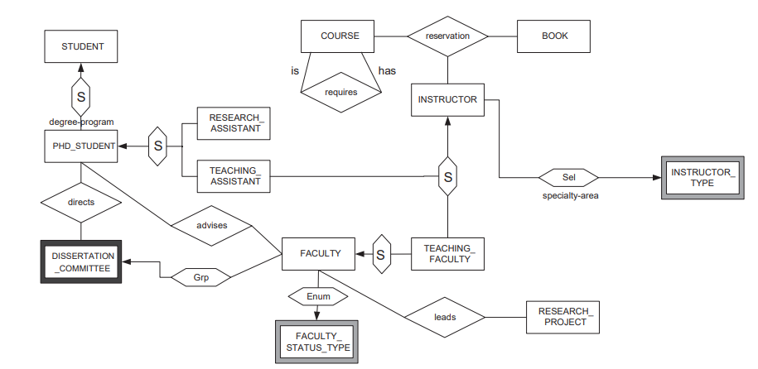

Fig:-EER diagram of Department.(Ram and Khatri, 2005)

All of these conditions, as seen in Fig. can be simply met by the schema by utilising the formalism offered by any semantic model. Although we employ USM as our basis model in this assignment, our methodology is not USM-specific. Each symbol in the schema depicted in Fig. has corresponding meanings, which are briefly discussed in the next section(Ram and Khatri, 2005).

This department's overarching policy is to encourage faculty members to be involved, maintain concentration, and the Ph.D. students in its general purpose of research and instruction, and promote student learning outside of the classroom. The database analyst may discover that some of these policies convert to several set-based carnality requirements for this department application after additional investigation. Each INSTRUCTOR has a maximum of three specialty areas. These specialty areas help the INSTRUCTOR focus and serve as the foundation for the department head's decision to assign an INSTRUCTOR teaching courses(Ram and Khatri, 2005). A specific BOOK and COURSE may only have a maximum of three reservations made by different INSTRUCTORS for various terms. Due to a staffing shortage, the librarian has chosen to only keep up to 500 different reservations. Reservations may or may not be made by an INSTRUCTOR;For an INSTRUCTOR, the library can only keep a maximum of 20 reservations, maybe due to a lack of processing power. Additionally, instructors are not permitted to reserve the same book for more than two of the courses they teach. This rule guarantees that students have a fair chance to acquire the reserved books' small number of copies. Each course has a prerequisite and/or has a prerequisite, and a course that participates in a required relationship can play one or two roles(Ram and Khatri, 2005).

## Task_3

A unique kind of ABAP (Advanced Business Application and Programming) called a logical database is used to obtain data from numerous tables that are connected to one another. A logical database additionally offers a read-only view of the data.Data is structured in a tree-like structure and kept as records that are connected to one another through edges in a logical database, which simply needs a hierarchical structure of tables. Open SQL statements are contained in the Logical Database and are used to read data from the database(Liu, Yin and Blanas, 2019b). The application programme receives data from the logical database line by line after it has read and, if necessary, stored the programme.

A specific view of Logical Database tables is offered by Logical Database. When the database's structure is complex, a logical database should be employed(Liu, Yin and Blanas, 2019b). It is practical to utilize flow, i.e

SELECT

SELECT * FROM Department;

READ

SELECT * FROM student;

PROCESS

SELECT * FROM Department;

Verifies the syntax of SQL and determines its validity. Example:

SELECT * FROM student;

This check indicates an incorrect spelling of FROM in this case.

The semantic check establishes whether or not the statement is meaningful. This check, for instance, determines whether the query contains a tablename that is not present.

Shared Pool check: Each query executes with a unique hash code. As a result, if the code is found in the shared pool, this check will tell the database to stop taking further optimization and execution measures.

DISPLAY

SELECT pno, pname FROM student WHERE color='BLUE';

DISPLAY;

## Task_4

CREATE DATABASE p2757368_department;

p2757368_department=# CREATE TABLE p2757368_student(id int, name char(10),degree_type char(20), degree_program char(20), PRIMARY KEY(id));

CREATE TABLE

p2757368_department=# CREATE TABLE faculty(f_id int, f_name char(10),factulty_status_type char(20), dept char(20), PRIMARY KEY(f_id));

CREATE TABLE

p2757368_department=# CREATE TABLE p2757368_faculty(f_id int, f_name char(10),factulty_status_type char(20), dept char(20), PRIMARY KEY(f_id));

CREATE TABLE

p2757368_department=# CREATE TABLE p2757368_Instructor(I_id int, I_name char(10),Instructor_type char(20), I_dept char(20), PRIMARY KEY(I_id));

CREATE TABLE

## Task_5

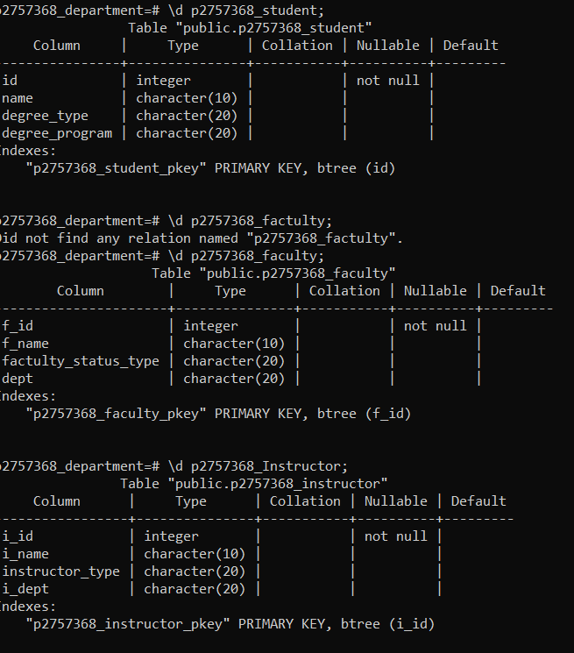

## Task_6

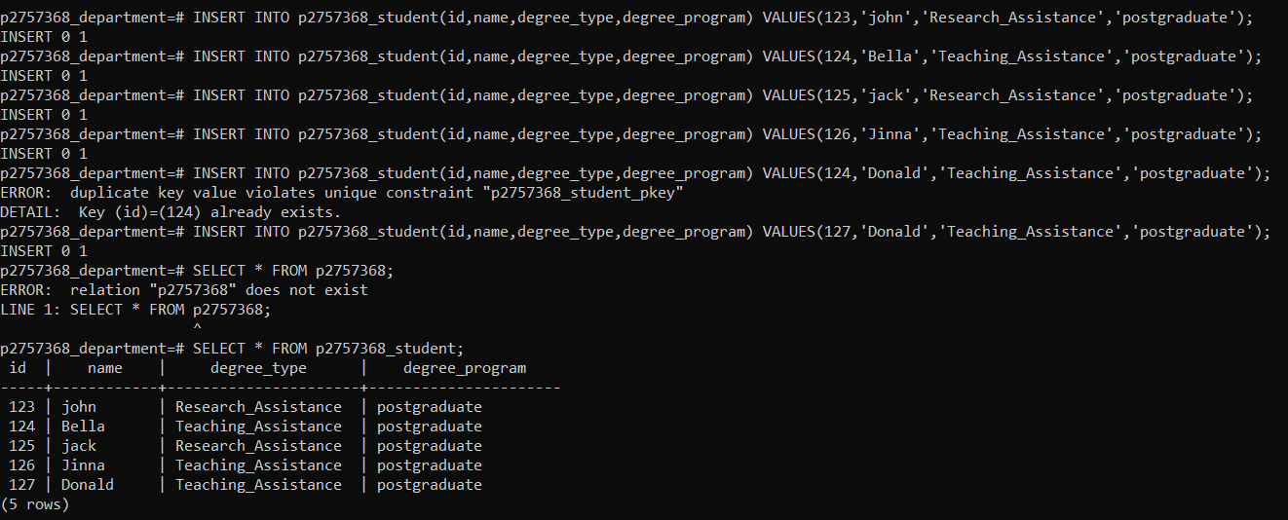

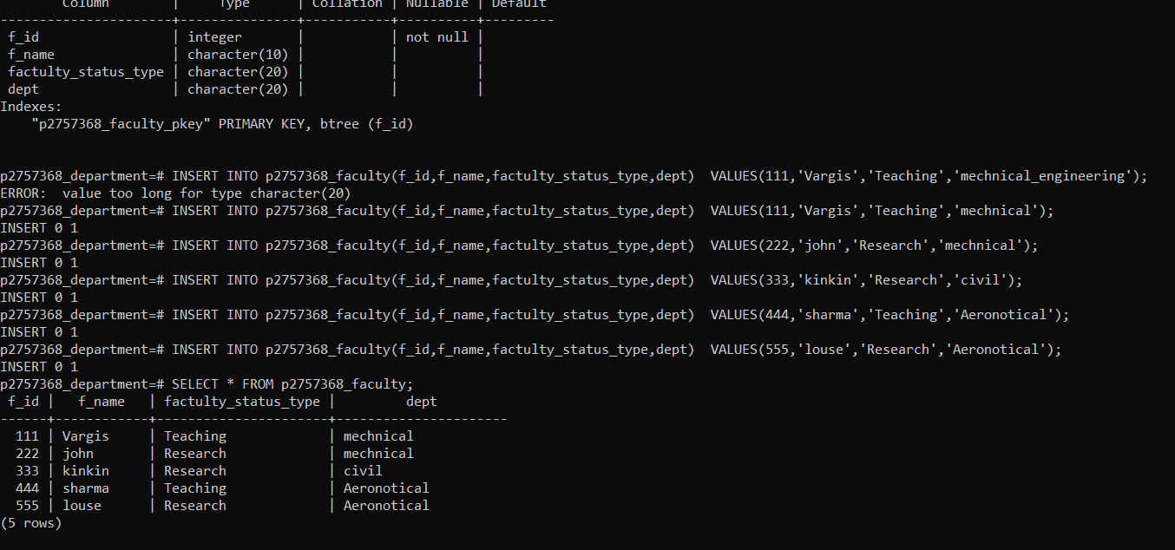

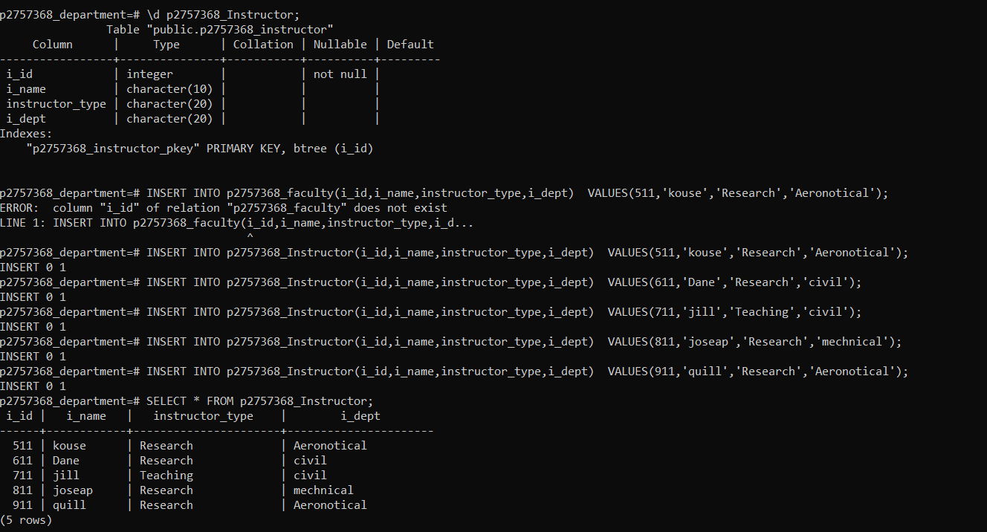

## Task_7

Selection of particular table columns

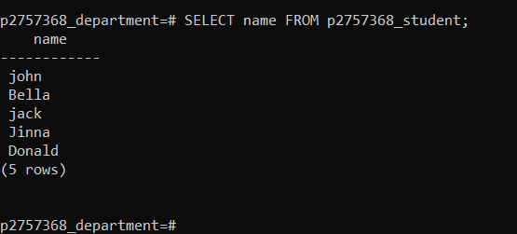

Inner Join of at least 2 tables

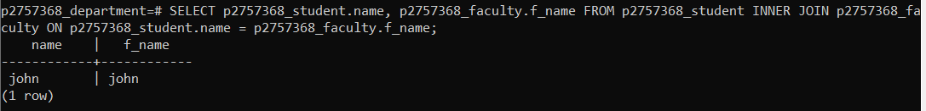

Outer Join of at least 2 tables

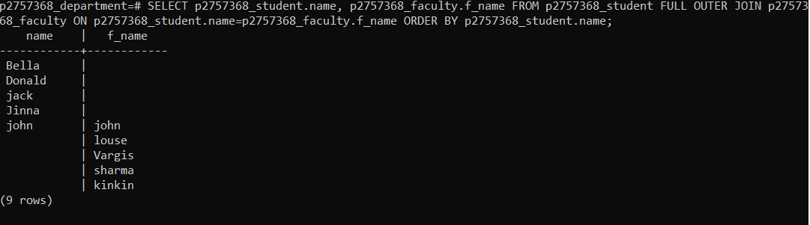

Use of count and/or another similar mathematical expression

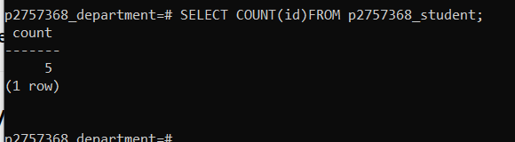

Use of a sorting/ordering facility

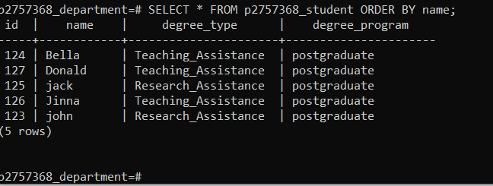

A condition using “<”, “>”, LIKE etc

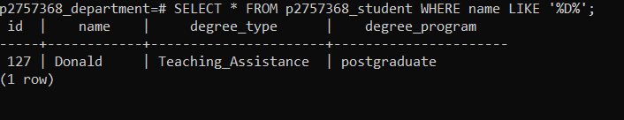

A condition using IN, NOT NULL, or similar

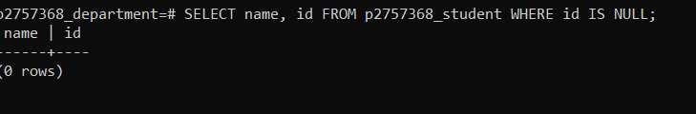

A sub-query

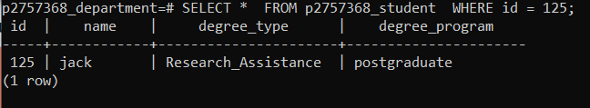

## Task_8

Taking care of information entails making sure it functions for us and is helpful for the jobs we complete. We can prevent unintentional disorganisation of the data we gather and contribute to a DBMS's database. It becomes easier to obtain and better incorporated into our overall job. By employing a database to manage information, we can strategically use the data we already have(Liu, Yin and Blanas, 2019b).

Because it comprises both the database itself and metadata that defines and explains the contents and relationships between tables in the database, a database system is referred to as self-describing. If necessary, database users or the DBMS software use this information. A database system is entirely different from the conventional file-based system in which the data definition is a component of the application programmes due to the separation of data and information about the data.If a user wants to modify the structure of a file, all the applications that access that file may need to be modified as well since under the file-based system, the structure of the data files is defined in the application programmes(Kraska et al., 2021).

The data structure is kept in the system catalogue rather than the programmes in the database method, on the other hand. As a result, altering the file's structure only requires one modification. Program-data independence is another name for this barrier between the programmes and the data(Kraska et al., 2021).

A database allows for several data perspectives. A view is a segment of the database that has been designated and tailored for specific system users. Different perspectives on the system may exist among its users. Only the information that a user or group of users find interesting may be included in each display.Multiple users are supported by the design of current database systems. In other words, they enable several users to view the same database concurrently. Concurrency control strategies are characteristics that allow access to this information. These techniques guarantee that the data are always accurate and that data integrity is upheld.Modern multiuser database systems are designed far better than earlier versions that only allowed one user at a time(Kraska et al., 2021).

In the database approach, each piece of data should ideally only be stored once. Data redundancy may still be necessary in some circumstances to increase system performance, but it is managed by application programming and kept to a minimum by include the least amount of redundancy possible while creating the database.There are many benefits to integrating all of an organization's data into a database system(Kraska et al., 2021). The first benefit is that it enables data sharing between staff members and other users of the system. In addition, users can produce more information from a given amount of data thanks to the integration than would otherwise be feasible.To guarantee that users submit accurate information and maintain data integrity, database management systems must offer the capability to set and enforce specific restrictions. A database constraint is a limitation or guideline that specifies what can be added to or changed in a table, such as the need that a postal code follow a specific format or that a genuine city be added to the City column.

Constraints on databases can take many different forms. The type of data that can be entered into a field, for instance, only numbers, depends on the data type. A primary key or other measure of data uniqueness assures that no duplicate entries are made. Constraints might be straightforward (field-based) or intricate (programming)(Kraska et al., 2021).

## Task_9

Incorporating, storing, organizing, and preserving the data generated and gathered by an organization is known as data management. A key component of implementing IT systems that power business applications and deliver analytical data to support operational decision-making and strategic planning by corporate executives, business managers, and other end users is effective data management(Kraska et al., 2021).

The goal of the data management process, which combines a number of distinct tasks, is to guarantee that the data stored in business systems is reliable, accessible, and current. Business users often engage in various portions of the process to ensure that the data fulfil their needs and to get them on board with regulations regulating it. IT and data management teams normally handle the majority of the required work.This in-depth explanation of data management includes information on its several disciplines, best practise for managing data, problems that firms must overcome, and the financial advantages of an effective data management strategy(Kraska et al., 2021).

Growing data volumes make data management more difficult, especially when there is a mix of structured, semistructured, and unstructured data. A company may also have isolated systems that are challenging to integrate and administer in a coordinated manner if its data architecture is poorly planned. Because of this, it is more difficult to guarantee that data sets are reliable and consistent across all data platforms(Kraska et al., 2021).

Enabling data scientists and other analysts to identify and access pertinent data can be difficult even in organisations with better planning, especially when the data is dispersed across numerous databases and big data systems. Many data management teams are developing data catalogues to describe what is available in systems and often contain business dictionaries, metadata-driven data, and other resources to help make data more accessible(Kraska et al., 2021).

While the rapid move to the cloud can make some areas of data management job easier, it also brings with it new difficulties. For enterprises that need to shift data and processing workloads from current on-premises systems, transitioning to cloud databases can be challenging. The cost of using cloud systems and managed services must be continuously controlled to ensure that data processing expenses do not go over budget. Costs are another significant concern with the cloud(Kraska et al., 2021).

The responsibility for maintaining corporate data security and reducing potential legal liability for data breaches or misuse now falls on many data management teams. Data managers must assist in ensuring adherence to industry and governmental rules around data security, privacy, and usage(Kraska et al., 2021).

Numerous jobs, responsibilities, and abilities are required for the data management process. In smaller companies with fewer resources, one employee may play several different functions. Data architects, data modellers, DBAs, database developers, data administrators, data quality analysts and engineers, and ETL developers are typically part of data management teams in bigger organizations. The data warehouse analyst, who assists in managing data in a data warehouse and creates analytical data models for business customers, is another profession that is becoming more prevalent(Kraska et al., 2021).

# Conclusion

This is to conclude that the above assignment has been done to the best of the knowledge and processes as asked in the assignment and has been try to solved all the given tasked and parameters as asked and finally the assignment database system and design has been completed and done.

# References

Ram, S. and Khatri, V. (2005). A comprehensive framework for modeling set-based business rules during conceptual database design. *Information Systems*, 30(2), pp.89–118. doi:10.1016/j.is.2003.10.008.

Liu, F., Yin, L. and Blanas, S. (2019b). Design and Evaluation of an RDMA-aware Data Shuffling Operator for Parallel Database Systems. *ACM Transactions on Database Systems*, 44(4), pp.1–45. doi:10.1145/3360900.

Kraska, T., Alizadeh, M., Beutel, A., Chi, E.H., Ding, J., Kristo, A., Leclerc, G., Madden, S., Mao, H. and Nathan, V. (2021). SageDB: A learned database system. *Other repository*. [online] Available at: https://dspace.mit.edu/handle/1721.1/132282.

Abdelhafiz, B.M. (2020). *Distributed Database Using Sharding Database Architecture*. [online] IEEE Xplore. doi:10.1109/CSDE50874.2020.9411547.

Chen, J., Song, Q., Zhao, C. and Li, Z. (2020). Graph Database and Relational Database Performance Comparison on a Transportation Network. *Communications in Computer and Information Science*, pp.407–418. doi:10.1007/978-981-15-6634-9_37.