A study on “Financial management of apple”

**Abstract**

This study mainly focuses on the financial management of apple. Apple has to move away from its exclusive and passive frameworks and toward one that is more open-minded and active and where the team is responsible for fulfilling the duties. The organization as a whole need to recognize the whole personnel in this way for exceeding expectations. This one will promote a friendly environment among some of the individuals, putting more focus on the value of teamwork and reducing the effect of fierce competition among employees.

Table of Contents

**1. Introduction** 5

**1.1 Background of Apple** 5

**1.2 Research aims and objectives** 5

**1.3 Review of major recent events over the past five years** 5

**2. Literature review** 6

**2.1 Income** 6

**2.2 Prices of Stock** 7

Figure 2- **Prices of Stock** 8

**2.3 Growth of Apple** 9

**2.4 Key Ratios** 9

**2.4.1 Profitability** 9

**2.4.2 Solvency and Liquidity** 10

**2.5 Equity and Liabilities Assets** 10

**2.5.1 Balance sheet** 10

Figure 6- **Equity and Liabilities Assets** 11

**2.6 Statement stockholder’s Equity** 12

**2.6.1 Cash Flow** 13

**2.7 Apple Dividend Analysis** 13

**2.7.1 Dividend Pay-out** 14

**2.7.2 Yield Dividend** 14

**2.7.3 Growth Dividend** 15

**3. Competitors** 15

**3.1 Intangible Apple Asset vs Rise of Samsung** 16

**3.2 Statistical Comparison** 16

**3.3 Market Share** 17

**3.3.1 Industry vs Apple** 17

**3.4 Face-off Direct** 17

**4. Strategic levers and Future Perspectives** 18

**4.1 Future Perspectives** 18

**4.1.1 Augment Reality** 18

**4.1.2 Virtual Reality** 18

**4.2 Apple Strategic Levers** 19

**4.3 Five Force Model Of PORTER** 20

**4.3.1 Competition in Industry** 20

**4.3.2 Buyers’ power of Bargaining** 21

**4.3.3 Risk of the New Entrants** 21

**4.3.4 Bargaining Power of Suppliers** 22

**4.3.5 Risk of customers choosing a different product** 22

**Part C** 22

**5. PBP, ARR, NPV of Apple** 22

**5.1 PBP** 22

**5.2 ARR** 23

**5.3 Npv** 23

**5.4 Calculation Part** 24

**6. Conclusion** 26

**References** 28

# **1. Introduction**

## **1.1 Background of Apple**

The landscape is constantly changing, and inventors from all over the world work tirelessly to advance society and provide people with the greatest possible quality of life. Steve Jobs was a member of the pioneers who aimed to use technology to revolutionize the world. Steve Jobs, an unorthodox leader with a bold business vision, created the much more important innovation in the history of technology. He served as Apple Inc.'s co-founder, CEO, and chairman. He served as PIXAR's president and was a big stakeholder. Following The Walt Disney Company during the period of PIXAR, he served on its board of directors (Enkel, Bogers, and Chesbrough, 2020). The pioneers of the microprocessor movement are often regarded as also being Steve Wozniak and Jobs, founder of Apple. Although duo Steve Jobs and Wozniak were Apple's biggest founders, It doesn't seem appropriate to mention their friend Ronald Wayne further since modern iPhones, iPads, and iMacs still wouldn't exist without him. Bruce was convinced by Steve Jobs to take 10% of the remaining stock and to act as a tyrant in the case in which he and Wozniak ran into problems, but Wayne quit the company 12 weeks ago, selling a portion for $500 that'd ultimately be worth $72 billion 40 years within next. The business offers all of its goods via direct salespeople, online shops, Apple store major retailers, distributors, third-party mobile network dealers having patent agreements having Apple, and online retailers. Additionally, the company sells a variety of items created by other companies that are incompatible with Apple, including software applications, many peripherals, and application software. The firm offers training, entrepreneurship, and managerial skills in retail to customers, small and mid-sized enterprises, and individuals. The 52 movements and postures span that concludes on the last Saturday in September constitutes the Company's fiscal year. The Company was established in California in 1977 (Enkel, Bogers, and Chesbrough, 2020).

## **1.2 Research aims and objectives**

1. 2022 will see a rise in its customer base from 17.4% to 17.9% as well as a total sale of 254 million units.

2. Help to maximize a fund's economic and financial advantages.

3. Additional revenue, a rise in profits higher profitability margins (Hu, Parlour, and Rajan, 2019).

## **1.3 Review of major recent events over the past five years**

**1. Change of directors**

Management, according to Shackleton (1995), is the method by which a person influences other group members to achieve the group or objectives of the organization. According to Northouse (1997), a key characteristic of management is that it is a method that involves both engaging a group and achieving a desired outcome. This is consistent with Shackleton's concept, which contends that a leader can influence followers to cooperate toward shared objectives. Considering the characteristics of a transformational, they tend to utilize their position of control and influence to radically alter, changing the old, established ways of achieving the desired objectives in favor of fresh, best interventions that are simple to implement. This represented the basic idea behind Job's methodical technique; he believed that only by thinking creatively, he might motivate the Apple staff to develop things that were not conventionally produced. He allegedly motivated the staff to "alter the term” (Abad-Segura et al., 2020).

**2. Profit warning and legal issue of Apple**

The mentioned previous sections iPod, which featured a manual joystick, could hold 1000 songs, and nevertheless only operated with Macs, was among Apple's product lines the previous time company issued a drop in profits. Since that time, a lot of things have changed. In a brief statement in June 2017, Steve Jobs cited the firm's "great products" while attributing the firm's quarterly sales decline (from $1.6 billion to $1.4 billion) to waning interest first from creative sectors (Kraus, Kraus, and Osetskyi, 2020).

# **2. Literature review**

**Financials**

Essential accounting is a method for assessing a business or organisation while bearing in mind a number of factors, such as earnings, share price, and statements of cash flow (Abad-Segura et al., 2020).

## **2.1 Income**

A time period's success is detailed in the financial statements. Deals come first, then operating earnings and diluted profits per share (EPS). Operating and non-operating expenses are the two categories that make up the income statement. Information regarding revenues and costs that are a direct result of routine business operations is disclosed in the operational part of the net income (Kraus, Kraus, and Osetskyi, 2020).

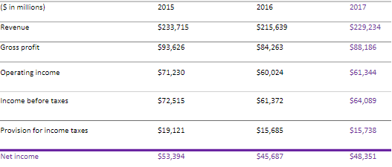

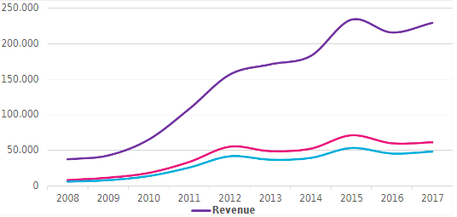

Figure 1- **Financial overview of apple**

Source- (Kraus, Kraus, and Osetskyi, 2020)

Again, for annual budgets from 2008 through 2017, Apple's net revenue also referred to as net income, is shown in the graph. Apple's net earnings for the 2016 fiscal year, which covered the period from October 2015 to September 2017, was about US$45.69 trillion. During the first quarter of 2017, Apple said that smartphone sales alone brought in 54 million dollars. A condensed financial statement is shown below (Kraus, Kraus and Osetskyi, 2020).

## **2.2 Prices of Stock**

Apple's stock price currently exceeds $175 and has significantly climbed in recent times, primarily as a consequence of Apple's innovative and courageous decision to remain viable in a very tough business (Shapiro and Hanouna, 2019).

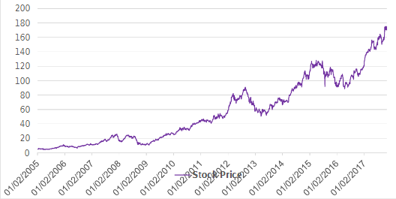

## Figure 2- **Prices of Stock**

Source- (Shapiro and Hanouna, 2019)

According to industry experts, Apple Inc. has a great future and shows little symptoms of suffering just at moment. Its stock price might rise by more than $200 if experts' projections come true (Moinina et al., 2018).

1 Tax reform

2. Service revenue

3. Valuation

4. Enterprise spending

5. iPhone

Many opponents assert that strong corporate spending on Apple merchandise and services, its rapid growth in assistance income, and all of these factors will increase the cost of Apple stock in 2018 (Shapiro and Hanouna, 2019).

An elevated iPhone is Apple's greatest important invention or precedent product, and it has had a substantial impact on the company's share price. Only four to five times in the six months after an iPhone launch has Apple Inc.'s share price decreased: 44% in the period immediately preceding the release of the iPhone 3G in 2008, 34% in the period immediately preceding the release of the Apple 5, the company is the biggest smartphone following the death of its founder Steve Jobs, and 8.19% in the period immediately following the announcement today of the iPhone 6S in 2015 (Moinina et al., 2018).

## **2.3 Growth of Apple**

The industry's stock and outstanding shares on the market are completely reliant on growth. Total sales are much higher if shares and efficiency are strong. Expansion is required to keep a competitive advantage or seize the customer base. 19 Financial information | Competitors Take various forms DI TORINO Businesses use performance statistics to raise the value of their stock, which represents the future of the company (Michels et al., 2023).

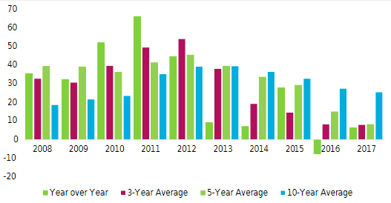

Figure 3- **Growth of Apple**

Source- (Michels et al., 2023)

## **2.4 Key Ratios**

### **2.4.1 Profitability**

Suitability ratios are a series of economic metrics that are used to assess a company's capability to generate revenues from its expenses and various other associated expenses over a particular period. When compared to a company's ratio or a similar proportion from a prior period, a higher value for the bulk of these ratios indicates that the team has grown (Melnychenko, 2020).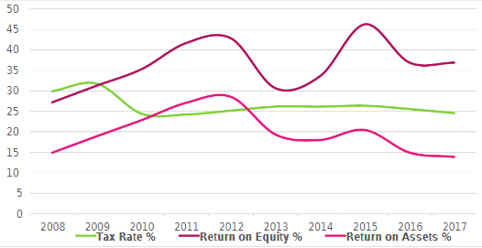

Figure 4- **Profitability**

Source- (Melnychenko, 2020)

### **2.4.2 Solvency and Liquidity**

Financial condition evaluates a company's ability to satisfy debt obligations and the margin of safety through the calculation of signals such as the conversion rate, rapid ratio, and operational cash flow in addition to the comprehension of current liabilities ratios about financial cash. The liquidity ratio is one of the many metrics used to evaluate a firm's capacity to meet its long-term commitments. Additionally, the stability ratio calculates a firm's after-tax income value, less sort of semi-costs, and compares it to the total of the company's existing debt (Li, 2022).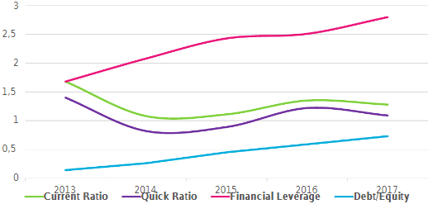

Figure 5- **Solvency and Liquidity**

Source- (Li, 2022)

## **2.5 Equity and Liabilities Assets**

### **2.5.1 Balance sheet**

A balance sheet is an accounting statement that lists the assets, liabilities, the owner’s equity of a corporation at a particular period. Investors may learn about the company's assets and obligations in addition to the amount of shareholders' equity from all these three financial statement sections. The following equation governs the capital structure: Liabilities plus owner equity equals assets (Guardia et al., 2019).

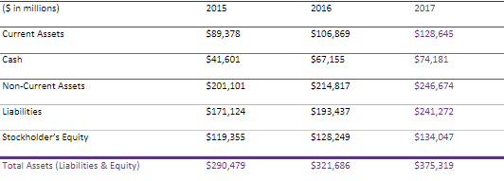

## Figure 6- **Equity and Liabilities Assets**

Source- (Guardia et al., 2019)

#### **2.5.1.1 Asset**

Materials that belong to a corporation and have measurable, quantifiable long-term economic worth represented in dollars. Samples include cash, investments, receivables, inventories, commodities, real estate, structures, machinery, or automobiles (Dimoso, Kassim, and Makule, 2022).

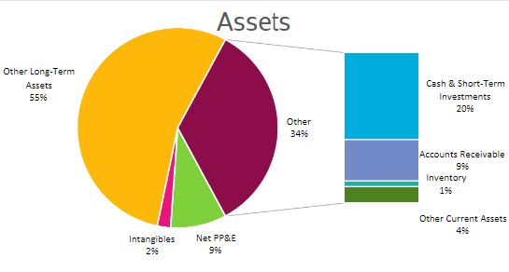

Figure 7- Assest

Source- (Dimoso, Kassim and Makule, 2022)

#### **2.5.1.2 Equity and Liabilities**

An obligation is a debt owed by a business that necessitates the firm give a financial advantage in today for transaction history or incidents. In contrast, equity represents the sum that the company has contributed to increasing the organization's profitability and productivity. Earnings are the sum that has been reinvested back into the company (Dalhaus et al., 2020).

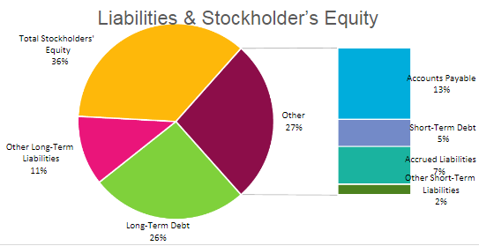

Figure 8- **Equity and Liabilities**

Source- (Dalhaus et al., 2020)

## **2.6 Statement stockholder’s Equity**

The report demonstrates the growth of equity over the course of an accounting cycle. All equity accounts which have an impact on the final related are shown on the summary of shareholders' ownership, including ordinary shares, operating income, paid-in capital, and dividends (Chen et al., 2022).

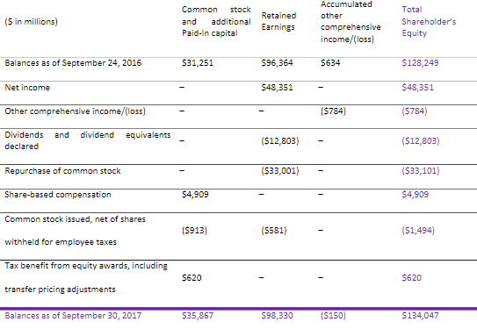

Figure 9- **Statement stockholder’s Equity**

Source- (Chen et al., 2022)

The company's cash flows are listed on the statement of cash flow. It aids in keeping track of annual investments and finances, which are reviewed at the end of the financial year to assess the bank's profitability and position within the market.

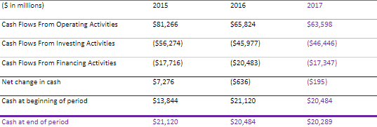

Figure 10- **stockholder’s Equity**

Source- (Brodnanova, Rovny and Moroz, 2022)

### **2.6.1 Cash Flow**

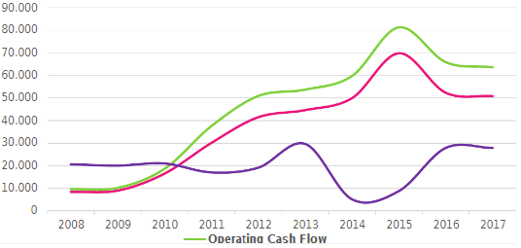

Figure 11- **Cash Flow**

Source- (Brigham and Daves, 2018)

## **2.7 Apple Dividend Analysis**

2012 marked the return of Apple Inc.'s dividend pay-outs after a 17-year hiatus. Just after its fiscal year 2011, this had amassed a stunning sum of money as well as other cash equivalent assets totaling more than a billion dollars from its early success with the iPad and iPhone. Since then, Apple has continued to boost its revenue and profits every year until 2015, allowing it to increase its annual earnings again for three years after the initial quarterly earnings installment in 2012. In calendar quarters 2 and 3 of the company's 2016 financial year, which ran from December 27, 2015, to June 25, 2016, the AAPL income continued to grow at a significantly faster pace (Nasution, 2019b).

### **2.7.1 Dividend Pay-out**

For the six months that included the corporation's economic Q2 and Q3 of 2016, Apple's net dividend came to $5.996 billion, surpassing previous profit pay-outs from two prior quarters in a row since it reinstated quarterly profits in 2012. The combined net profit for the third and second quarters of 2016 was $18.321 billion, putting the profit at payment percentage for those 6 months was 32.7%. This analysis looks at the three years between 2013 and 2015 and the average profit charge percentage of 25.9%. With only an aggregate accumulated capitalization of $119.4 billion as of September 26, 2015, the conclusion of Apple's fiscal year 2015, the higher quarterly dividend percentage for as long back as a half year was due to Apple's consistent five-year growth in revenue and profit (Nasution, 2019b).

This is in comparison to a holding of $41.6 billion that same day in actual cash, cash counterparts, and here-and-now investments. Customers were satisfied with the optimal cash balance at 34.8% of Apple's generate revenue as Apple pondered returning perhaps more of its capital to shareholders for their usage in 2016 (Brigham and Daves, 2018).

### **2.7.2 Yield Dividend**

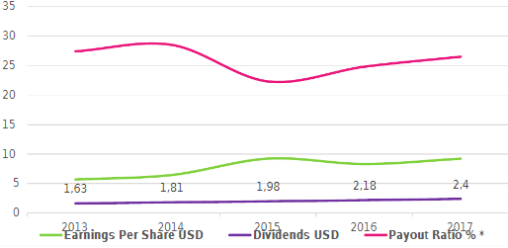

Figure 12- **Yield Dividend**

Source- (Moinina et al., 2018)

Profit yield is more advantageous to those with a lofty goal of achieving investment gains, whereas a high dividend is a measure of financial quality often used as an element of the first assessment of stock speculation. The capital expansion of a business is secondary to the dividend income it may provide for dividend shareholders. The profit yield of a stock examines the yearly dividend as a percentage of the price of the financial markets. Considering how much a stock pays in profits, for a single financial specialist, their purchase expenses on a company may raise or reduce their return yields (Tougeron and Hance, 2021).

As of June 25, 2016, Apple's playout on a following-year basis was $2.13 per piece annually. The investment return for Apple shares was 1.98% to use the stock's final cost of $107.57 on August 25, 2016. Even though Apple's net revenue has consistently increased since the company's 2012 profitability restoration, the price has sometimes risen at far greater speeds, which may have resulted in the benefits return becoming less concentrated for new investors buying the shares at premium prices. Wads of cash speculators will be seeing advancements in their profit yields if Apple is centered on a strong and growing financial system (Moinina et al., 2018).

### **2.7.3 Growth Dividend**

A payout decrease is not the norm, but rather a rare circumstance for the majority of firms. After a little time, depending just on the growth of their and showcasing as well as income through activities, organizations may want to increase their dividend. From December 27, 2015, to June 25, 2016, AAPL earned $5.996 billion in profit, a tiny increase of 2.5%, and over-revenue produced in the preceding six months. With annual profit installments of $10 billion in 2012 given the quarterly earnings of $2.5 billion, a halfway-year installment in that year, annual earnings growth for the three years between 2013 to 2015 reached a median of 4.6%. In comparison, the projected rate of dividend growth for the six months also included Apple's third and fourth quarters of 2016 only marginally bit higher than that of the company's current dividend growth rate (Tougeron and Hance, 2021).

# **3. Competitors**

1. Oppo

2. Samsung

3. Google

## **3.1 Intangible Apple Asset vs Rise of Samsung**

Besides developing and constructing PCs, Apple has made tremendous strides regarding product delivery. Apple has a central position within the technological world, putting it during the most progressive era of our history. The business has a unique asset that elevates it to the top of both customers' and economists' perceptions. But now that Samsung has consistently increased its share of the market, Apple is under the greatest threat. Samsung latest more money from the sale of 63 million Galaxy devices than it did from all of Google's business divisions combined (Pardo and Borges, 2020).

Despite this, Samsung's ability to produce income is still much behind that of Apple. Amazingly, Apple sold 1.32 billion iPhones in 2016, and it appears probable that it will continue to outnumber Samsung's Galaxy range for some time. Whatever the case, it was no longer a given that Apple will remain to lead in the industry of mobile phones (Melnychenko, 2020).

## **3.2 Statistical Comparison**

Elevated smartphones account for the bulk of worldwide iPhone sales in terms of volume, but they also earn the most money. Apple's enormous profits from cell phones may be attributed to the fact that each iPhone it produces costs around $200 to produce yet sells for over $800 or $1,000. Since luxury cell phones have a larger impact on total sales margins than almost any other work manufactured by businesses in a given industry, Apple earns more money selling the iPhone than any luxury smartphone produced either by Samsung or Google, its main competitors (Pardo and Borges, 2020).

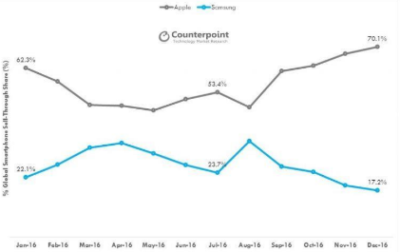

Figure 13- Samsung vs Apple market share

Source- (Melnychenko, 2020)

According to Counterargument, Apple and Samsung are constantly battling for their lives. Their various expensive mobile phone bargains are a "zero-total amusement"; as one company fails its supply of the profitable phone offers, the supply from the other organization grows. After the Note 7 tragedy, Samsung is in a very low position, and it's going to look into the major overhauling shift in 2017–18 to fight with Apple once more (Melnychenko, 2020).

## **3.3 Market Share**

Within the same time of 2016, there were around 432 million tons of cell phones sold to end users globally, a rise of 7% over the comparable time in 2015. Apple overcame Samsung to keep its position as the top phone manufacturer globally (Guardia et al., 2019).

### **3.3.1 Industry vs Apple**

The regular season of 2016 was most notable for Samsung's loss of the top place to Apple. Apple sold almost 250 million iPhones in Q4 2016, or over double the 71.5 million units it delivered in the same quarter this same previous year. Apple devices have 17.9% of the phone market as a result of this development, a 2% increase from the previous year. Samsung, on the other hand, 's market share dropped from 20.7 percent to 17.8 percent as a result of a dip in sales from 83.4 million to 76.7 million (Chen et al., 2022). Apple and Samsung both had a share of the market decline to emerging Chinese juggernauts like Huawei and Oppo, both of whom saw their share rise year over year. Due to Oppo and Huawei's domination of the Asian market over the previous several quarters, this remarkable trend has emerged. Android certainly has the advantage in this situation, at least so far as operating systems are worried. Android, the software platform developed by Google, now retains 81.7% of the marketplace, a 1% annual decline. While iOS maintains 17.9% of the market, up.2 percent compared to the previous year (Guardia et al., 2019).

## **3.4 Face-off Direct**

Samsung anticipates that the huge demand for Apple's iPhone X devices would hinder sales of its devices, therefore the firm will likely only slightly delay the manufacturing of its elevated models inside the fourth quarter of 2017. According to Huffington Post, Samsung will sell 77 million devices overall in its fourth quarter, a 5% decline from its charity sector. Apple's actions for Q4 2017 serve as the basis for estimates of iPhone X sales. The company projects earnings of $84 to $87 billion, a significant increase above the old record quarterly earnings of $78 billion established in Q4 2016. Samsung, in comparison, debuted two of its flagship models earlier this year and is now anticipating the arrival of the Galaxy S9 at the start of 2018 (Chen et al., 2022).

# **4. Strategic levers and Future Perspectives**

## **4.1 Future Perspectives**

### **4.1.1 Augment Reality**

Asked the majority of technology companies which product will replace your smartphone, and the appropriate response is likely to center around a smartwatch for "augmented reality," the technique that superimposes cutting-edge images over this actual world. While virtual reality replaces the actual world with a fake one, VR technology enhances one's present sense of reality (Michels et al., 2023).

Microsoft has launched HoloLens in recent years. Google already has begun work on a project named Project Tango that is intended for Android and may eventually lead to the development of Google Glasses. A few months ago, Facebook announced its interest in wearable technology. Mark Zuckerberg even said that one day, AR (Augmented Reality) glasses will eliminate the need for the majority of screens in daily life. Apple's strategy is distinctive. Apple didn't host any TED lectures or augmented reality demonstrations to show that eventually, all you'll need is a set of eyeglasses as just a computer. Instead, it begins with anything well iPhone and iPad (Dimoso, Kassim, and Makule, 2022).

Apple will shut down the biggest AR platform as soon as IOS 11 is successfully made accessible on millions of smartphones. It will work considerably better with existing technology rather than cutting-edge eyeglasses or headphones. Apple will deploy it with a simple software update, giving them a strong benefit over other AR rivals. That won't be a clear advantage right away, of course, and it definitely won't convey the kind of amazing information that companies like Magical Leap are launching. iPhones with AR capabilities will undoubtedly include some gaming and entertainment software. It's going to be possible for you to create video game characters while seated on your tabletops (Michels et al., 2023).

### **4.1.2 Virtual Reality**

While some other large tech firms are now extremely concerned with augmented worlds, Apple has been hesitant about it for a long period. But now that Apple believes the moment is ripe, it will provide a cutting-edge set of resources that will be included in the future macOS sierra system and give developers the to connect Virtual reality headsets (Dimoso, Kassim and Makule, 2022).



Figure 14- **Virtual Reality**

Source- (Dimoso, Kassim and Makule, 2022)

## **4.2 Apple Strategic Levers**

Apple announced recently that it will invest $3.9 billion in new procurement contracts for prepaid stock and capital spending. Presale payments for capital expenditures in LGD, TMD, and Sharp were evident. It begins to divide the industry between the two major groups of Apple and Samsung. Furthermore, it has been reported that Apple has secured 60% of the touch-sensitive limit that the industry had expected. It demonstrates the advantage of a well-planned essential contractual arrangement, which may result in decreased financial concerns and the ability to surpass competitors (Awasthi et al., 2021).

In certain electrical equipment, LCDs account for up to 85% of the value of the item, and businesses have begun to realize that significant changes must be made to ensure an advantage. It is also undeniable that the entertainment industry is one of multifaceted quality and susceptibility, with wide variations in valuation and obvious shifts in innovation directions. LTPS and AMOLED are currently highlighted. Key replies to source, where the speculative stakes are larger but as a consequence of real advantage, are all in style till further notice. Apple has undoubtedly used its position and a crucial supply strategy that was intentionally developed to build up its future company in the small to medium-sized business space and distract competitors during the meantime. It is important to note that there are differences between the economy of a single section and a big panel LCD (Economic Viability of the Commercial Cultivars of Apple in Jammu Province, 2019).

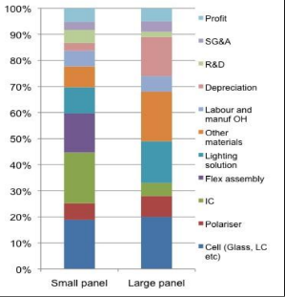

Figure 15- **Apple Strategic Levers**

Source- (Awasthi et al., 2021)

## **4.3 Five Force Model Of PORTER**

### **4.3.1 Competition in Industry**

Inside the computer industry, there is tremendous competition between each of the large companies that compete directly with Apple. Apple currently faces direct concurrence from like Google, Inc., Hewlett-Packard, Samsung Electronics Ltd., and Amazon, Inc. Each one of these companies spends a large amount of money on marketing, research, and development similar to Apple (R&D). As a consequence, the region is dominated by fierce rivalry. Because moving is so inexpensive, the industry is very relentless. It does not necessitate a significant outlay of cash on the side of the user to go from an Apple iPad to a Kindle or another tablet device. Apple has more or less coped with the threat of market competition by continually developing new products that stand out to strengthen or advance its position in the marketplace (Awasthi et al., 2021).

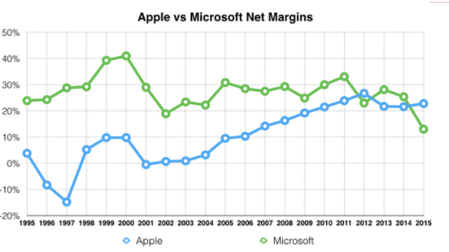

Figure 16- **Competition in Industry**

Source- (Dalhaus et al., 2020)

### **4.3.2 Buyers’ power of Bargaining**

Low switching costs increase customer purchasing power, which is a crucial consideration for Apple. The two main topics for further investigation in this force are the individual negotiating power with buyers and negotiating power. Apple has little bargaining power because each lost customer merely generates a little amount of profit for the corporation. Nevertheless, the aggregate market power of customers as well as the possibility of widespread losing customers to competition are formidable pressures. Through continuing to make significant financial expenditures in research and development, which enables it to consistently create innovative products like Apple Pay and the Apple Watch, as well as by boosting general customer loyalty, Apple helps combat this strong effect. Apple has indeed been fairly successful in establishing an enormous customer base in this highly competitive marketplace that, in fact, just wouldn't consider moving from it its iPhones to those of a competing phone maker (Dalhaus et al., 2020).

### **4.3.3 Risk of the New Entrants**

It is indeed doubtful that a fresh competitor would pose a significant threat to Apple's customers. This is mostly due to 2 variables: the prohibitively high costs associated with starting a firm in a region and the goes further to say expenditures associated with increasing brand awareness. Every newcomer to the desktop computer or mobile markets must have a significant sum of money to expend exclusively on R&D and manufacturing to develop and create its product range before really putting its products onto the market and beginning to generate money. Such newcomers would face some well tough competition in the market among Apple and its main competitors, all of whom are sizable, well-established companies. Creating a brand's awareness in a market wherein numerous companies have already exceptional brand recognition, such as Amazon or Google is another issue (Dalhaus et al., 2020).

### **4.3.4 Bargaining Power of Suppliers**

The component suppliers' sectors, including those, are hugely competitive businesses that produce laptop CPUs. With such a little price premium, switching suppliers for Apple will only provide a tiny hurdle. Furthermore, the bulk of Apple's manufacturers and suppliers value their business relationships with the corporation and are hesitant to worry about losing Mac as a customer. As a consequence, Apple does indeed have a stronger negotiation power over its vendors whereas rivals have weaker negotiating strategies. The negotiation power of the clear process makers is not taken into consideration by Apple or its leading competitors (Ren et al., 2022).

### **4.3.5 Risk of customers choosing a different product**

Replacement goods are options for a company's business rather than ones that compete directly with it in the framework of Porter's Five Forces Theory. In the instance of Apple, a landline that can be used instead of an iPhone is a real illustration of a substitute product. This competitive rivalry is rather low for Apple since the vast majority of potential alternatives have less functionality than Apple devices, such as a landline phone versus an iPhone with the ability to do more than simply make phone calls (Li, 2022).

# **Part C**

# **5. PBP, ARR, NPV of Apple**

## **5.1 PBP**

This phrase "usable life" denotes the period required to recover the initial financial investment. In those other terms, it is the period when a piece of machinery, facility, or other property has produced moderate amounts of income to cover all of its capital costs (Ren et al., 2022).

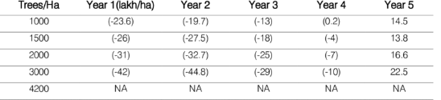

Figure 17- **PBP**

Source- (Li, 2022)

## **5.2 ARR**

A financial rate of return is the yearly capital gain an asset is predicted to generate divided by its usual operating cost, expressed in a percentage each year (ARR). To use the accounting rate of return formula, working capital evaluations are made (Li, 2022).

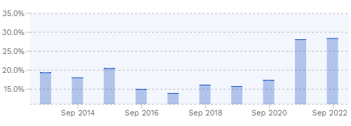

Figure 18- **ARR**

Source- (Nasution, 2019)

|  |  |  |
| --- | --- | --- |
| Date | TTM Net Income | ROI (Return on investment) |
| 2019 | $65.50B | 31.90% |
| 2018 | $67.96B | 31.91% |
| 2017 | $70.89B | 32.02% |

Table 1- Apple ROI historical data

## **5.3 Npv**

Npv method in this context refers to the disparity between the present value of cash flows or withdrawal over time (NPV). The NPV is employed in capital planning and investment planning to assess the financial viability of development proposals (Nasution, 2019).

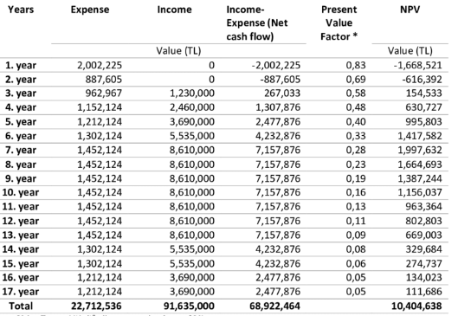

Figure 19- **Npv**

Source- (Brodnanova, Rovny and Moroz, 2022)

## **5.4 Calculation Part**

**Discount rate is 8.73 Percent**

|  |  |  |
| --- | --- | --- |
| Year | Projected | Cash Flows |
|  | A | B |
| 0 | -103 | -115 |
| 1 | 10 | 60 |
| 2 | 30 | 40 |
| 3 | 50 | 60 |
| 4 | 65 | 5 |

**Calculation of Depreciation of Project A and Project B:**

Calculation of Depreciation of Project A is as follows:

Description of Project A = Initial Investment – Scrap Value/ Number of Years

= 103 – 0/ 4

= 25.75 million

Calculation of Depreciation of Project B is as follows:

Description of Project B = Initial Investment – Scrap Value/ Number of Years

= 115 – 0/ 4

= 28.75 million

Calculation of Payback Period of Project A is as follows:

**Calculation of payback Period of Project A**

|  |  |  |
| --- | --- | --- |
| **Year** | **Cash Flow in Millions** | **Cumulative Cash Flow** |
| Initial Investment | -103 |  |
| 1 | 10 | 10 |
| 2 | 30 | 30 |
| 3 | 50 | 80 |
| 4 | 65 | 145 |

Payback Period = 2.769

**Calculation of payback Period of Project B**

|  |  |  |
| --- | --- | --- |
| **Year** | **Cash Flow in Millions** | **Cumulative Cash Flow** |
| Initial Investment | -115 |  |
| 1 | 60 | 60 |
| 2 | 40 | 100 |
| 3 | 60 | 160 |
| 4 | 5 | 165 |

Payback Period = 54.4

Payback Period for Project A is 2.769 years

Payback Period for Project b is 54.4 Years

**Calculation of Accounting Rate of Return and Net Present Value for Project A**

|  |  |  |  |
| --- | --- | --- | --- |
| **Year** | **Cash Flow in Millions** | **Depreciation** | **Net Profit After tax** |
| Initial Investment | -103 |  |  |
| 1 | 10 | 25.75 | -15.75 |
| 2 | 30 | 25.75 | 5.75 |
| 3 | 50 | 25.75 | 24.25 |
| 4 | 65 | 25.75 | 39.75 |

Average Net profit = 10.25

Average Investment = -58.5

Accounting Rate of Return = 22.67%

Net Present value = $ 5.23

**Calculation of Accounting Rate of Return and Net Present Value for Project B**

|  |  |  |  |
| --- | --- | --- | --- |
| **Year** | **Cash Flow in Millions** | **Depreciation** | **Net Profit After tax** |
| Initial Investment | -115 |  |  |
| 1 | 60 | 28.75 | 31.25 |
| 2 | 40 | 28.75 | 11.25 |
| 3 | 60 | 28.75 | 31.25 |
| 4 | 5 | 28.75 | -23.25 |

Average Net profit = 10

Average Investment = 48

Accounting Rate of Return = 20.23%

Net Present value = $ 8.23

Payback Period of Project A is 2.769 years and Project B is 54.4 years

Accounting Rate of Return for Project A is 22.67% and project B is 20.23%

Net Present Value for Project A is 5.23 million and for Project B is 8.23 million

# **6. Conclusion**

Apple must give up its exclusive or passive architecture in favor of one that is more openly inclusive and due to the significance of the group in job completion. The company in its entirety should do it to thank the whole staff for meeting their objectives. This will encourage a friendly environment among some of the individuals, putting greater focus on the value of teamwork and reducing the effect of workplace competition competitions. The article society and new workplace standards will be established via teamwork. As was already said, Apple's task mentality is unsustainable since it requires its workers to put in unreasonably long hours. The organization should implement a different shift structure or even more accommodating hours while taking into account both the employees' individual and professional lives. The only factors influencing how workers will perform, their attitude at work, and the way they will start behaving as people in the organization's marketing strategy are organizational culture, leadership, and structure. There's no denying that Apple employs a more entrepreneurial mindset and invests in its staff to boost productivity. Apple's positive outlook is unquestionably one main reason why it has been the world's leading firm in technical progress. The business has to reinforce its core roots and get rid of internal strengths and weaknesses that may be catastrophic for the company's future growth and profitability as long as it is expanding and opening subsidiaries all over the globe.

# **References**

Abad-Segura, E., González-Zamar, M.-D., López-Meneses, E. and Vázquez-Cano, E. (2020). Financial Technology: Review of Trends, Approaches and Management. *Mathematics*, 8(6), p.951. doi:10.3390/math8060951.

Awasthi, M.K., Ferreira, J.A., Sirohi, R., Sarsaiya, S., Khoshnevisan, B., Baladi, S., Sindhu, R., Binod, P., Pandey, A., Juneja, A., Kumar, D., Zhang, Z. and Taherzadeh, M.J. (2021). A critical review on the development stage of biorefinery systems towards the management of apple processing-derived waste. *Renewable and Sustainable Energy Reviews*, [online] 143, p.110972. doi:10.1016/j.rser.2021.110972.

Brigham, E.F. and Daves, P.R. (2018). *Intermediate Financial Management*. [online] *Google Books*. Cengage Learning. Available at: https://books.google.com/books?hl=en&lr=&id=ipRUEAAAQBAJ&oi=fnd&pg=PP1&dq=Financial+management+of+apple+company&ots=k-qcSjTZN_&sig=nN0hjOF5aiea520Rxh4AFLfMLbE [Accessed 17 Dec. 2022].

Brodnanova, R., Rovny, P. and Moroz, S. (2022). Competitiveness and Innovations in Foreign Trade: a Case of Apples from Slovakia to Czechia. *Marketing and Management of Innovations*, 2(1), pp.43–54. doi:10.21272/mmi.2022.2-04.

Chen, R., Zhang, C., Xu, B., Zhu, Y., Zhao, F., Han, S., Yang, G. and Yang, H. (2022). Predicting individual apple tree yield using UAV multi-source remote sensing data and ensemble learning. *Computers and Electronics in Agriculture*, [online] 201, p.107275. doi:10.1016/j.compag.2022.107275.

Dalhaus, T., Schlenker, W., Blanke, M.M., Bravin, E. and Finger, R. (2020). The Effects of Extreme Weather on Apple Quality. *Scientific Reports*, [online] 10(1). doi:10.1038/s41598-020-64806-7.

Dimoso, N., Kassim, N. and Makule, E. (2022). *Cashew apple in Tanzania: status of utilization, challenges, and opportunities for sustainable development*. [online] f1000research.com. Available at: https://f1000research.com/articles/11-1354 [Accessed 17 Dec. 2022].

Economic Viability of the Commercial Cultivars of Apple in Jammu Province. (2019). *Indian Journal of Economics and Development*, [online] 15(2). Available at: https://www.indianjournals.com/ijor.aspx?target=ijor:ijed1&volume=15&issue=2&article=013 [Accessed 17 Dec. 2022].

Enkel, E., Bogers, M. and Chesbrough, H. (2020). Exploring open innovation in the digital age: A maturity model and future research directions. *R&D Management*, 50(1), pp.161–168. doi:10.1111/radm.12397.

Guardia, L., Suárez, L., Querejeta, N., Rodríguez Madrera, R., Suárez, B. and Centeno, T.A. (2019). Apple Waste: A Sustainable Source of Carbon Materials and Valuable Compounds. *ACS Sustainable Chemistry & Engineering*, [online] 7(20), pp.17335–17343. doi:10.1021/acssuschemeng.9b04266.

Hu, A.S., Parlour, C.A. and Rajan, U. (2019). Cryptocurrencies: Stylized facts on a new investible instrument. *Financial Management*, 48(4), pp.1049–1068. doi:10.1111/fima.12300.

Kraus, K., Kraus, N. and Osetskyi, V. (2020). New quality of financial institutions and business management. *Baltic Journal of Economic Studies*, [online] 6(1), pp.59–66. Available at: https://elibrary.kubg.edu.ua/id/eprint/31204/.

Li, Y. (2022). Analysis on the Driving Factors and Countermeasures of the Changes of Apple Production Distribution in the Loess Plateau. *Frontiers in Business, Economics and Management*, 5(3), pp.121–124. doi:10.54097/fbem.v5i3.1991.

Melnychenko, O. (2020). Is Artificial Intelligence Ready to Assess an Enterprise’s Financial Security? *Journal of Risk and Financial Management*, 13(9), p.191. doi:10.3390/jrfm13090191.

Michels, M., Luo, H., Weller von Ahlefeld, P.J. and Mußhoff, O. (2023). Compliance with pre-harvest interval rules in apple production—A comparative analysis of green nudges among fruit growers and agricultural students in Germany. *Journal of Behavioral and Experimental Economics*, [online] 102, p.101963. doi:10.1016/j.socec.2022.101963.

Moinina, A., Lahlali, R., MacLean, D. and Boulif, M. (2018). Farmers’ Knowledge, Perception and Practices in Apple Pest Management and Climate Change in the Fes-Meknes Region, Morocco. *Horticulturae*, 4(4), p.42. doi:10.3390/horticulturae4040042.

Nasution, D.A.D. (2019a). The Effect of Implementation Islamic Values and Employee Work Discipline on The Performance of Moslem Religious Employees at Regional Financial Management in the North Sumatera Provincial Government. *INTERNATIONAL HALAL CONFERENCE & EXHIBITION 2019 (IHCE)*, [online] 1(1), pp.1–7. Available at: https://journal.pancabudi.ac.id/index.php/ihce/article/view/552.

Nasution, D.A.D. (2019b). The Effect of Implementation Islamic Values and Employee Work Discipline on The Performance of Moslem Religious Employees at Regional Financial Management in the North Sumatera Provincial Government. *INTERNATIONAL HALAL CONFERENCE & EXHIBITION 2019 (IHCE)*, [online] 1(1), pp.1–7. Available at: https://journal.pancabudi.ac.id/index.php/ihce/article/view/552.

Pardo, A. and Borges, P.A.V. (2020). Worldwide importance of insect pollination in apple orchards: A review. *Agriculture, Ecosystems & Environment*, 293, p.106839. doi:10.1016/j.agee.2020.106839.

Ren, C., Ting, I.W.K., Lu, W. and Kweh, Q.L. (2022). Nonlinear effects of ESG on energy‐adjusted firm efficiency: Evidence from the stakeholder engagement of apple incorporated. *Corporate Social Responsibility and Environmental Management*. doi:10.1002/csr.2266.

Shapiro, A.C. and Hanouna, P. (2019). *Multinational Financial Management*. [online] *Google Books*. John Wiley & Sons. Available at: https://books.google.com/books?hl=en&lr=&id=gDLDDwAAQBAJ&oi=fnd&pg=PR19&dq=Financial+management+of+apple+company&ots=hfI_utLqwv&sig=VjZDFQi9AxE1a2BXDKEQ6drAotc [Accessed 17 Dec. 2022].

SINGH, P. (2022). COMPANY ANALYSIS OF APPLE. *Dtu.ac.in*. [online] doi:http://dspace.dtu.ac.in:8080/jspui/handle/repository/19661.

Tougeron, K. and Hance, T. (2021). Impact of the COVID-19 pandemic on apple orchards in Europe. *Agricultural Systems*, p.103097. doi:10.1016/j.agsy.2021.103097.

Vuddaraju, A.V. (2022). Workplace Violence at Apple Inc. as a Result of Prejudice. doi:10.14293/s2199-1006.1.sor-.ppvvcrv.v1.